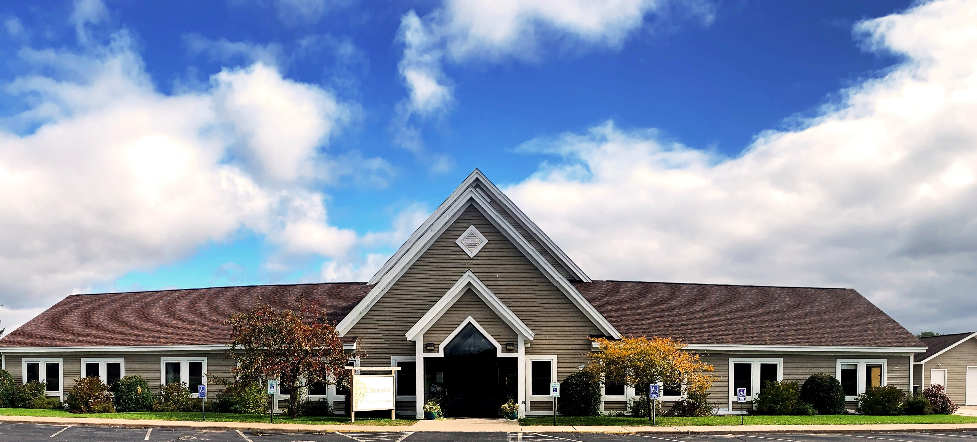

EAST BALSAM BAPTIST
CHURCH PROFILE

EAST BALSAM BAPTIST CHURCH
1816 108th STREET
BALSAM LAKE, WISCONSIN 54810

TABLE OF CONTENTS

WHO ARE WE LOOKING TO LEAD US? 3
WHAT DO WE BELIEVE? 4
WHERE DID WE COME FROM? 6
WHAT ARE SOME INTERESTING FACTS FROM OUR HISTORY? 7
WHO ARE WE TODAY? 8
WHAT IS OUR BALSAM LAKE COMMUNITY LIKE? 9
WHAT ARE THE DEMOGRAPHICS OF OUR AREA? 10
WHO ARE THE MEMBERS OF THE PASTORAL SEARCH COMMITTEE? 12
WHAT HAS OCCURRED SINCE OUR PASTOR RESIGNED? 13

WHO ARE WE LOOKING TO LEAD US?

At this season in our church’s life, we are fervently praying for a pastor who is able to provide dynamic leadership that respects the work of our lay leaders and staff while building and maintaining a strong collaborative relationship with them.

It is of utmost importance for our pastor to have a rich, intimate and growing relationship with the Lord; we rely on him to regularly encourage us to remain faithful to our core beliefs (as defined by our conference, Converge Great Lakes Baptist Conference, and as stated in our church profile), and to equip us to fulfill our God-directed mission.

We desire a pastor who is preferably seminary-trained, with pastoral experience, able to effectively teach and preach the Word of God in its entirety at an intermediate level in a biblically sound and relationally engaging style, able to effectively communicate to both those who are far from Christ as well as to those who are more mature in their walk with the Lord.

It is vital for our next pastor to focus on discipleship and internal spiritual growth while emphasizing prayer and evangelism/outreach.

We desire a pastor who is relationally warm, confident, committed, and humble with the ability to lead the congregation well through weekly prayer and preaching/teaching.

Above all, we desire for lives to be transformed by the Gospel of Jesus Christ and are praying for a pastor who exemplifies this same passion.
WHAT DO WE BELIEVE?

- THE WORD OF GOD: We believe the Bible is the Word of God, fully inspired and without error in the original manuscripts, written under the inspiration of the Holy Spirit, and that it has supreme authority in all matters of faith and conduct. (II Timothy 3:16; II Peter 1:20, 21; Mark 13:31)
- THE TRINITY: We believe there is one living and true God, eternally existing in three persons, that these are equal in every divine perfection, and that they execute distinct but harmonious offices in the work of creation, providence and redemption. (Genesis 1:1; John 1:1, 3; Matthew 28:19-20)
- GOD THE FATHER: We believe in God, the Father, an infinite, personal spirit, perfect in holiness, wisdom, power and love. We believe that He concerns Himself mercifully in the affairs of all people, that He hears and answers prayer, and that He saves from sin and death all who come to Him through Jesus Christ. (Luke 10:21-22; Romans 1:7; Matthew 23:9)
- JESUS CHRIST: We believe in Jesus Christ, God’s only begotten Son, conceived by the Holy Spirit. We believe in His virgin birth, sinless life, miracles and teachings. We believe in His substitutionary atoning death, bodily resurrection, ascension into heaven, perpetual intercession for His people, and personal visible return to earth. (Matthew 1:18-25; John 1:1; 20:28; Ephesians 1:4)
- THE HOLY SPIRIT: We believe in the Holy Spirit who came forth from the Father and Son to convict the world of sin, righteousness, and judgment, and to regenerate, sanctify, and empower all who believe in Jesus Christ. We believe that the Holy Spirit indwells every believer in Christ, and that He is an abiding helper, teacher and guide. (John 14:16, 17; Romans 8:9; Galatians 5:22-26)
- REGENERATION: We believe all people are sinners by nature and by choice and are, therefore, under condemnation. We believe that those who repent of their sins and trust in Jesus Christ as Savior are regenerated by the Holy Spirit. (John 3:14; Romans 9:22; Ephesians 2:4-5)
- THE CHURCH: We believe in the universal church; a living spiritual body of which Christ is the head and all regenerated persons are members. We believe in the local church, consisting of a company of believers in Jesus Christ, baptized on a credible profession of faith, and associated for worship, work and fellowship. We believe God has laid upon the members of the local church the primary task of giving the gospel of Jesus Christ to a lost world. (Ephesians 2:19-22; Acts 1:8; Hebrews 10:23-25)
- CHRISTIAN CONDUCT: We believe Christians should live for the glory of God and the well-being of others; that their conduct should be blameless before the world; that they should be faithful stewards of their possessions; and that they should seek to realize for themselves and others the full stature of maturity in Christ. (I Corinthians 10:31; Romans 12:1-3; Colossians 1:9-10).

- THE ORDINANCES: We believe the Lord Jesus Christ has committed two ordinances to the local church: baptism and the Lord’s Supper. We believe Christian baptism is the immersion of a believer in water into the name of the triune God. We believe the Lord’s Supper was instituted by Christ for commemoration of His death. We believe these two ordinances should be observed and administered until the return of the Lord Jesus Christ. (Matthew 28:18-20; Romans 6:3-5; I Corinthians 11:23-26).
- RELIGIOUS LIBERTY: We believe every human being has direct relations with God, and is responsible to God alone in all matters of faith; that each church is independent and must be free from interference by any ecclesiastical or political authority; that therefore Church and State must be kept separate as having different functions, each fulfilling its duties free from dictation or patronage of the other. (I Timothy 2:5; Romans 14:7-9, 12)
- CHURCH COOPERATION: We believe local churches can best promote the cause of Jesus Christ by cooperating with one another in a denominational organization. Such an organization, whether it is the Conference or a district conference, exists and functions by the will of the churches. Cooperation in a conference is voluntary and may be terminated at any time. Churches may likewise cooperate with interdenominational fellowships on a voluntary independent basis. (Acts 15:36, 41; Galatians 1:1-3; Revelation 1:4, 10-11).
- THE LAST THINGS: We believe in the personal and visible return of the Lord Jesus Christ to earth and the establishment of His kingdom. We believe in the resurrection of the body, the final judgment, the eternal felicity of the righteous, and the endless suffering of the wicked. (Matthew 16:27; I Thessalonians 4:15-18; Revelation 20:4-6; 11-15)
WHERE DID WE COME FROM?

In the year 1904, twenty members of the El Salem Baptist church who lived in the East Balsam and Bunyan communities decided to organize a local church. Thus, in connection with a three-day series of “Deeper Life” meetings, the Swedish Baptist Church of Bunyan, Wisconsin, was organized on Sunday, October 9th, in the home of Peter Alen. Peter Alen, with his family, had emigrated from Sweden in 1893 and settled on the eastern shore of Balsam Lake to be near eight other families that had come from the Dalarna province in Sweden.
It was decided to call the church the Swedish Baptist Church (Svenska Baptist Forsamlingen) of Bunyan, Wisconsin. At that time, there was a post office at the Bunyan corner about a mile northeast of the present church building, hence the Bunyan address.
Thirty-two years would pass before the church would have a full-time pastor in 1936. Money was scarce and so was the availability of preachers. The congregation continued to meet in homes, in the Bunyan School, and later in the East Balsam School, until the church building was completed in 1910.
From the day of organization, the new congregation talked of building their own church. In November 1904, a building committee was chosen consisting of Ole Alen, Andrew Palm, Andrew Peterson, and Peter Peterson. Land was purchased from Mrs. Francis Haskins on December 18, 1909, for $40 as the deed is recorded in the Polk County Courthouse. Additional land was received as a gift from Lawn Randall in 1946 when the parsonage was built. Another 25 feet was purchased from John Randall in 1961 to enlarge the parsonage lawn.
In 1910, the church, with a full basement, was built at the cost of about $2,700. Money was borrowed from the Polk County Bank and from the Northern Baptist Convention. The old “kassa-bok” (expense ledger) has a complete record of costs connected with the building. The road used to go around the east side of the pond by the old church building. East Balsam School was on the right-hand side of the road.
In 1913, a horse barn was built to accommodate the faithful animals that brought the worshippers to church. This barn stood south of the church. Later a garage was built in approximately the same spot as the horse barn had been. In July of 1982, the decision was made to build a Sunday School Annex—a building separate from and north of the church.

This provided space for four classrooms. The cost was about $15,000. In 1990, a ramp was added for easier access with a wheelchair or for those who found it hard to walk steps.
Finally, in 2002, the congregation moved the church from its old church building into the new house of worship just a mile up the road.
WHAT ARE SOME INTERESTING FACTS FROM OUR CHURCH HISTORY?

- One of the distinguishable early members of the church was John Huss. Huss was a descendant of the great reformer, John Huss, who was considered a heretic and was burned at the stake on July 6, 1415. During that time of persecution in Bohemia, some of his family fled to Sweden, and so it was that some of his descendants were among the emigrants coming from the province of Dalarna to the East Balsam community.
- The church instated its first full-time pastor in 1936.
- Depression days influenced the finances of the church. At the end of 1936, the church treasury was $2.55 in the red. John Dahm gave $3.00 so the church started the new year with 45 cents in the treasury.
- The church held its first Vacation Bible School in 1937.
- East Balsam has been the “first church” for nine young pastors, and the church has prospered through the years under their ministries.
- Three young ladies who grew up attending East Balsam Baptist Church, along with their husbands, became foreign missionaries.
- Four families within our congregation are descendants of the charter members.

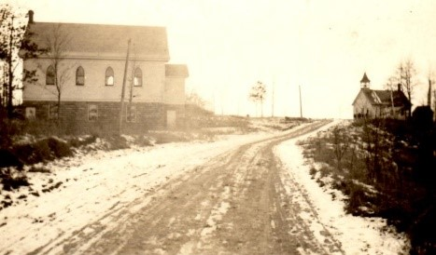
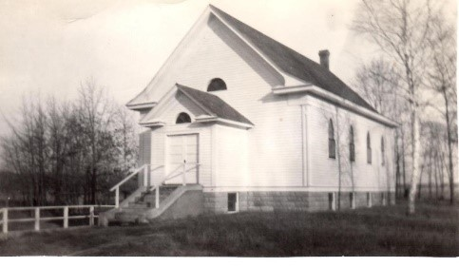
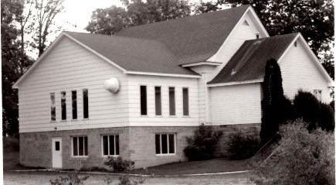
WHO ARE WE TODAY?
1943
1974
1910

We are East Balsam Baptist Church (EBBC), and by the grace of God, we have an abundant history of over 100 years of Christ-centered ministry in the Balsam Lake, WI area. Our congregation has grown to a beautiful, multigenerational blend of 110 members and regular attendees. This number climbs by an average of 10 people during the summer months due to the beautiful lake country in which we live. On any given Sunday year ’round, we’re invigorated by lots of energetic children, graced by believers who are in their later seasons of life, and blessed by all generations in between. We are a body of Christ-followers devoted to spiritual growth through the divinely inspired Word of God, the power of prayer, and the generous use of our time, God-given abilities and passions to impact our church family as well as our neighbors both near and far.

In addition to worshipping together in a weekly Sunday morning service followed by a warm and rich time of fellowship, various members of the body gather weekly for prayer, Bible studies, and youth group, as well as assisting with a variety of outreaches throughout the year.

At East Balsam Baptist, we value allowing and encouraging our body of believers to use their God-given gifts to serve, inspire and strengthen the church family. Here are some of the areas in which our congregation uses its gifts on a 100% volunteer basis to partner with the Holy Spirit and make our church the vibrant place it is:
- The worship team, which often includes children and youth
- The weekly fellowship time, which includes snacks and beverages, following the Sunday service
- The children’s church leaders and support team
- Both men’s and women’s ministry
- VBS

WHAT IS OUR BALSAM LAKE COMMUNITY LIKE?

East Balsam Baptist Church is located 5 miles east of the quaint village of Balsam Lake in northwestern Wisconsin on 15 acres of peaceful prairie, sprinkled with pine trees and surrounded by farms, residences of rural working families, and vacation homes that line the breathtaking nearby lakes. Balsam Lake is situated 15 miles northeast of St. Croix Falls, WI and Taylors Falls, MN, which are located in the heart of the stunning St. Croix River Valley. Population in our stable, rural community has experienced little fluctuation in recent years and is projected to remain steady. Our church membership and participation come from throughout the area.
The church is located on 108th Street in the middle of beautiful country cornfields. There are 12,589 people residing in a 10-mile radius. Approximately 19 churches are located within this radius.
The racial and ethnic group diversity in the Balsam Lake area is low with 93.9% of the population being Caucasian.
The Balsam Lake community is somewhat traditional with 65.9% of the families being married couples with children, which is higher than the national average. College graduates account for 28% of those over the age of 25 years. The average annual household income in the community is around $71,702.

WHAT ARE THE DEMOGRAPHICS OF OUR AREA?
The following statistics are from an independent research organization whose data is compiled from three sources: Percept, Claritas and the U.S. Census Bureau; the data pertains to the area within a 10-mile radius of East Balsam Baptist Church.

HOW MANY PEOPLE LIVE WITHIN 10 MILES OF THE CHURCH?
Currently, there are 12,589 persons residing within 10 miles of the church. This represents an increase of 143 or 1.1% since 2000. During the same period, the U.S. grew by 17.0%.

IS THE POPULATION IN THIS AREA EXPECTED TO GROW?
The population in this stable, rural area is not expected to grow dramatically between 2019 and 2024. During the same period, the U.S. population is projected to grow by 3.6%.

HOW MUCH LIFESTYLE DIVERSITY IS REPRESENTED?
The lifestyle diversity in the area is low with only 15 of the 50 U.S. Lifestyles segments represented. The top individual segment is Rural Working Families representing 71.8% of all households. Some of the other U.S. Lifestyle segments represented in the area are Established Country Families, Working Country Consumers and Mature Country Families.

HOW DO RACIAL OR ETHNIC GROUPS CONTRIBUTE TO DIVERSITY IN THIS AREA?
Based upon the total number of different groups present, the racial/ethnic diversity in the area is somewhat low. Among individual groups, Anglos represent 93.9% of the population and all other racial/ethnic groups make up just 6.1% which is well below the national average of 40%. The largest of these groups, Native-Americans/Others, accounts for 3.5% of the total population. Hispanics/Latinos are projected to be the fastest growing group increasing by 18.0% between 2019 and 2024.

WHAT ARE THE MAJOR GENERATIONAL GROUPS REPRESENTED?
The largest age group in terms of numbers is Survivors (age 38 to 58) comprised of 3,351 persons or 26.6% of the total population in the area. Boomers (age 59 to 76) make up 26.1% of the population which is high compared to the national average of 18.2%.

OVERALL, HOW TRADITIONAL ARE THE FAMILY STRUCTURES?
The area can be described as somewhat traditional due to the above average presence of married persons and two-parent families.

HOW EDUCATED ARE THE ADULTS?
91.6% of the population aged 25 and over in the area are high school graduates as compared to the national average of 87.3%; college graduates account for 17.9% of those over the age of 25 in the area versus 31.0% in the U.S.

WHAT IS THE LIKELY FAITH RECEPTIVITY?
Overall, the likely faith involvement level and preference for historic Christian religious affiliations is somewhat high when compared to national averages.

WHAT IS THE LIKELY GIVING POTENTIAL IN THE AREA?
Based upon the average household income of $71,702 per year and the likely contribution
behavior in the area, the overall religious giving potential can be described as somewhat low.

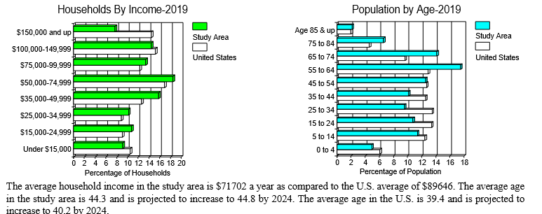

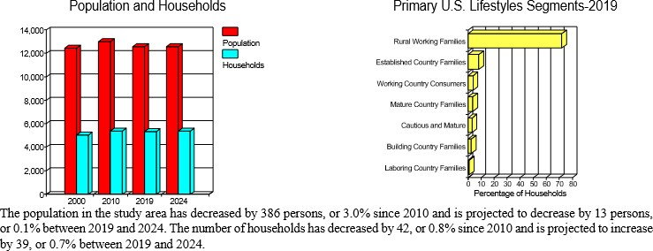
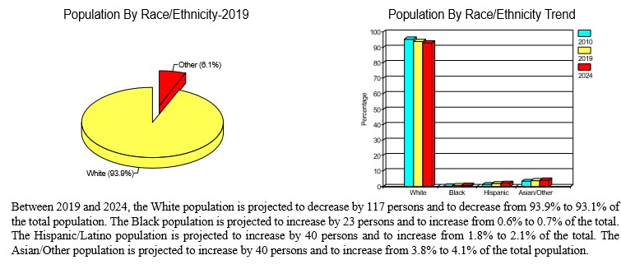

WHO ARE THE MEMBERS OF THE PASTORAL SEARCH COMMITTEE?

Sarah Bowers
Fred Hall*
John Larson
Lisa Lundquist
Adam Majeske*
Brian Matson
Larry Michaelson, Chair*
Craig Peters
Roger Peterson*
LaVonne Richter

*Members of the Deacon Board

PASTORAL SEARCH COMMITTEE
East Balsam Baptist Church
1816 108th Street
Balsam Lake, WI 54810
pastoralsearch@eastbalsam.org

WHAT HAS OCCURRED SINCE OUR PASTOR RESIGNED?

In the summer of 2019 our senior pastor of eight years, who was loved and respected, communicated to the church deacons that he believed the Lord was leading he, his wife and their young family to end their season at East Balsam Baptist Church. Prior to their departure, we held a warm farewell reception for the pastoral family, including a time of prayer and sharing. Since then, we have had one of a variety of pastors and teachers preach from the pulpit each Sunday.

The pastoral search committee was established shortly after our pastor’s departure, and we (the search committee) began our work by meeting with Gary Harrison from Converge Great Lakes Baptist Conference. He led us through a few options we could consider in searching for our new pastor. We made the decision to use the conference as our liaison and support as we seek the man whom God will use to shepherd us in this new season.

During the fall months, we had a demographical cross-section of our church body complete a Natural Church Development survey to help determine the strengths and weaknesses of our church. We also hired an independent research organization to provide us with statistical data for our geographical area, which allows us to better understand the community surrounding our church. Following this, we administered a congregational survey for individuals in the church body who are 16 years of age or older in order to help us understand what our church most desires in our next pastor. We used the results of these three tools to complete our Lead Pastor Job Description and Church Profile.

In November, we hired an interim pastor to help lead our church body as we prayerfully search for a new pastor. He joined us in early December.

We are holding a weekly prayer gathering devoted primarily to praying for the Lord to lead us to our next pastor and to lead our next pastor to us. We are calling upon and trusting in the Lord, knowing this season is an opportunity for us to grow deeper in our walk with Him.

