**EARLY HISTORY**

**“O Lord, not to us but to your name be the glory, because of your love and faithfulness.”**

As we look at the faithful members of East Balsam Baptist Church who have served God in the past, we are awed by the fact that they trusted in God with a vision and persistence amidst circumstances that to us living in 2019 seem impossible. To God be the glory for those faithful pioneers. East Balsam Baptist has always been a small church, however, there are many faithful Christians scattered around the U.S.A. and the world because of the ministry here in Balsam Lake.

**God proved His love and faithfulness in providing people with a vision …**

In the year 1904, twenty members of the El Salem Baptist church who lived in the East Balsam and Bunyan communities decided to organize a local church. Thus, in connection with a three-day series of “Deeper Life” meetings, the Swedish Baptist Church of Bunyan, Wisconsin, was organized on Sunday, October 9th, in the home of Peter Alen.

Peter Alen, with his family, had emigrated from Sweden in 1893 and settled on the eastern shore of Balsam Lake to be near eight other families that had come from the Dalarna province in Sweden.

The Alen family, along with other believers in the area, became members of the El Salem church, which was organized in 1894. The El Salem church was located approximately fifteen miles from East Balsam. Transportation before the days of the automobile was difficult so they began having Sunday School and meetings in their own homes. In due time they felt the need to organize their own church.

On Sunday afternoon, October 9, 1904, Rev. F. O. Carlson and A. Berg from Grantsburg; A. Paulson, Fred Hanson, Eric Hillberg, and Carl Olstrom from El Salem; and Nels Nelson, State Missionary*, met with the assembly.

The ordination council voted A. Paulson to lead the meeting and Nels Nelson as secretary. F. O. Carlson read Scripture, led in prayer and welcomed the believers for membership in God’s church. A. Paulson read I Timothy 3:15 and spoke concerning God’s church grounded in His Word. C. A. Berg gave a talk about baptism and communion.

The 20 charter members held hands and formed a circle. Nels Nelson went into the ring, led in prayer, and declared the church organized.

Peter Alen Peter S. Alen Andrew Palm, Sr.

Margreta Alen Olaf Erickson Margreta Palm

Olaf Alen Breta Erickson Peter Peterson

Andrew Alen John Huss Mary Peterson

Erick Alen Anna Huss Marie Peterson

Mary Alen Fred Lindstrom Andrew Peterson

Christina Alen Anna (Alen) Lindstrom

Andrew Palm Sr. was elected to be the church chairman, John Huss to be secretary, and Andrew Peterson to be treasurer. Andrew Palm and Peter Alen were elected to serve as deacons.

*The State Missionary’s job was to start churches in Wisconsin and Upper Michigan.

It was decided to call the church the Swedish Baptist Church (The Svenska Baptist Forsamlingen) of Bunyan, Wisconsin. At that time there was a post office at the Bunyan corner about a mile northeast of the present church building, hence, the Bunyan address.

Brother Palm spoke to the new church regarding the importance of her witness in the community and in the world, saying that English as well as Swedish would have to be used if they were to be effective witnesses.

Distinguished within this early group was John Huss, a descendant of the great reformer, John Huss, who was considered a heretic and burned at the stake July 6, 1415. During that time of persecution in Bohemia, some of his family fled to Sweden and so it was that some of his descendants were among the emigrants coming from the province of Dalarna to the East Balsam community.

**The church begins to grow**

Carl Holin, Breda Erickson, Jennie Huss, and Margreta Peterson joined the church on October 22, 1904. On December 5th, Elva Alen, the new bride of Andrew Alen, became a member.

In May 1905, the congregation asked S. A. Nelson to come from El Salem once a month to conduct services. Other El Salem pastors – Nels Nelson, A. Paulson, Johan Lundeen, and Carl Seaquist also ministered through the years.

State Missionary F. O. Carlson had a vital interest in the church and for many years came once a month to visit and preach. In June 1917, he offered to come on Friday for the Ladies Aid and then stay for the weekend.

Thirty-two years would pass before the church would have a full-time pastor. Money was scarce and so was the availability of preachers. The congregation continued to meet in homes, in the Bunyan School, and later in the East Balsam School, until the building was completed in 1910.

**History of Some Early Members**

**Holin:** Carl Holin, a layman but diligent Bible student, filled the pulpit at many services. He also traveled about in northwestern Wisconsin doing evangelistic work. Born in Dalarna, Sweden, he came to America in 1901 and settled in Balsam Lake.

Christina Alen became the bride of Carl Holin in 1916 and except for a three-year transfer of membership to Elim Baptist in Minneapolis, Minnesota, was a member for 50 years. Christine was pianist and church clerk for many years. Carl, at his death in 1951, had been a member for 44 years. Christine (Alen) Holin was the last of the 20 charter members to go home to be with the Lord on July 14, 1954. Daughter Maybelle and sons Victor and Robert put their faith in Christ and became baptized believers.

Carl Holin was a talented artist and in 1929 presented the church with a five-foot by six-foot hand-painted copy of Hofmann’s “Christ in the Temple”. This masterpiece graced the front of the church for many years and has been placed in the sanctuary of the new building.

Early services were held in Swedish with both English and Swedish being used for Sunday School classes. In August 1914, there is record of the purchase of 12 Swedish song books and 25 English song books.

**Dahm:** In 1910, Andrew Dahm Sr. and wife Christina, along with daughters Anna and Christina, son John and brother Peter became members of the church. John and Anna were faithful members of the church for many years. John was a carpenter and did a lot of building for the church. The Dahms remembered the church in their will; in 1971, the church received $9,000, which became the down payment for an extensive building project enlarging the church to double its size, both basement and upper auditorium.

**Solin:** Carrie Solin became a member of the church in 1916. Although gone some time to practice her profession as a registered nurse, she maintained her membership and vital interest in the church for 45 years until her death in 1961. On many occasions she loaned money to the church without interest. She taught Sunday School for many years and also played the organ.

**Hanson:** Rev. Harry Hanson, who had married Florence Huss, daughter of John Huss, moved to this community with his family in November 1921. He had graduated from a seminary in Morgan Park, Chicago, Illinois, and had served as a colporteur missionary in Montana for eight years. Harry Hanson preached at many services. The family left the area in 1939; however, their son and daughter-in-law, Clifford and Ruth Hanson, worshiped at East Balsam during the summer for many years.

**Should the church continue or close the doors?**

We have been told of at least two occasions when things looked bleak and the church wondered if they should continue to struggle on.

One Sunday in the very early days, Andrew Alen and his brother Ole were the only ones to show up for Sunday School. Andrew said, “We might as well give up,” to which Ole replied, “Even if there are only two of us, we will continue on.”

**“For where two or three come together in my name, there am I with them.”**

Matthew 18:20 NIV

Quoting a letter from Axel Rendahl (State Missionary from 1925-1932) referring to year 1927 – “My first visit to East Balsam stands out now. I had written to Carl Holin and when I came, he said, ‘We have not arranged any meeting for you. We have closed up and quit.’ Well, after some talking, I said, ‘I have blind evangelist Freeman. For a week could we not come?’ It was so decided and we had a good work. How many youngsters were baptized I don’t remember, but the church took on new life and has been going and growing ever since – all glory to God.”

The meetings to which Axel Rendahl refers were held in October. In November seven young people were baptized by Mr. Rendahl – Maybelle Holin, Verna Arvidson, Frances Norlund, Jeanette Hanson, Clifford Hanson, Lucille Ogren, and Paul Alen. What if Axel Rendahl had not come at that time and arranged for special meetings? Surely it was the leading of the Lord.

Jeanette Hanson recalls, “After these meetings we young (in age) converts began having little prayer meetings by the baptistry steps and top of the stairs (to the basement). Soon we organized as the Plus Ultra Band. We had regular meetings with singing, prayer and testimonies.”

**Changes—**

On October 28, 1928, the congregation voted to change the name of the church to East Balsam Baptist Church.

At the annual meeting on November 16, 1929, the church voted to make English the official language. Church minutes are in Swedish up to this date; they have been translated into English. It was not until 1949 that the church constitution was translated from Swedish to English.

**Pastors**

**God proved His love and faithfulness in providing pastors with a vision—**

The church did not have a full-time pastor until 1936.

**N. Werner and Lilly Nelson**

**June 1936 – January 1940**

Rev. N. Werner Nelson began his ministry as the church’s first full-time pastor in June of 1936. With him were his wife, Lilly, and sons, Ira and Ebert. They also had two older sons, Hilding and Gordon. Both Werner and Lilly were born in Sweden. They had served several churches prior to coming to Balsam Lake.

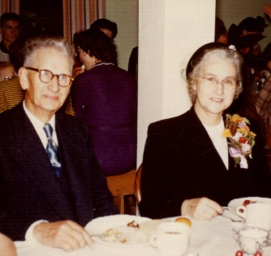

A rented house in Balsam Lake would serve as a parsonage. The church requested aid from the State and General Conference to help pay the pastor’s salary of $50 per month.

Mrs. Nelson was active in the Ladies Aid, as a Sunday School teacher, entertaining visiting pastors, and accompanying her husband on home and hospital calls.

“Julotta” – a traditional early Christmas Day service was conducted in those days. It would be dark and cold, the roads sometimes icy, yet people would meet at church at 6:00 a.m. Later, it became customary to have a service at midnight on Christmas Eve rather than early Christmas morning. In approximately 1990 we began having a 4:00 p.m. service on Christmas Eve, which continues to the present (2019).

Depression Days had an effect on the finances of the church. At the end of 1936, the church treasury was $2.55 in the red. John Dahm gave $3.00 so the church started the new year with 45 cents in the treasury. The Ladies Aid apparently was active, for on January 17th they gave the church $40.

In 1937, the church voted to conduct Daily Vacation Bible School. Through the years the church has continued to have “Kid’s Meetings” or Vacation Bible School every summer.

In 1933, Wood Lake Bible Camp, located near Grantsburg, was begun. Young people from the church have gone to camp for many years. Pastors and adults have gone to be counselors and teachers. NOTE: Wood Lake Bible Camp was discontinued this year (2019) and the property has been sold.

In 1939, the church was wired for electricity. About this time a communion set with individual cups was purchased. Prior to that time, a common cup was used. Pastor Werner Nelson concluded his ministry at East Balsam on January 1, 1940, but continued to live in Balsam Lake until about 1951.

**Stan and Lillian Rendahl**

Stan was the son of Axel Rendahl who was State Missionary from 1925 to 1932. Stan wrote a brief review of his ministry at East Balsam, which must have been the winter of 1940 as Rawlin Johnson came in June of that year.

“Officially I was never a pastor at Balsam Lake, but one winter I preached there with regularity. Mr. Arvidson would say, ‘Can you come next Sunday?’ and if I said ‘yes’ he would pick me up on his way home from his Twin City employment and I’d spend the weekend in Balsam Lake. This went on for months; until Easter, when he asked the same question, I replied, ‘I have a long-standing invitation to be in Upper Michigan for an Easter Sunrise service in one church and to preach in another on Sunday.’ He commented, ‘Then send someone else.’ I asked Rawlin Johnson to go and the Balsam Lake church called him to be the student pastor and he stayed three years. Those months of commuting to Balsam Lake were a real blessing to me and I loved the people.”

Stan Rendahl again filled the pulpit in June of 1997 when the church was without a pastor.

**Rawlin and Pearl Johnson**

**June 1940 – October 1943**

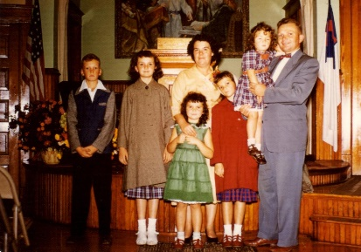

Beginning in June of 1940, Bethel Seminary student Rawlin Johnson came out to pastor the church for the summer. He continued every weekend during the next school term, and then came full-time. Rawlin came as a single man and stayed at the home of Miranda, Paul, and Irvin Alen until his marriage to Pearl Peterson in June 1942. They established their first home in an apartment arranged for them in the Dahm home. Maren Louise, their first child, was born during their ministry here. Five more children were born into their family—David, Carolyn, Janet, Nancy, and Dwight.

* On May 2, 1942, Pastor Rawlin officiated at his first wedding, that of Paul Alen and Lola Burch.
* In May of 1943, the church entertained the council meeting and ordination service for Pastor Rawlin Johnson.
* In June of 1943, a decision was made to start a “Parsonage Fund”.

Pearl was a homemaker, a friend to the people, went calling with the pastor, contributed vocally in song, and helped with the youth program.

Pastor Rawlin appreciated the willingness of the church to accept a young student and give him a start, the warm hospitality and faithfulness of God’s people, and Carl Holin’s encouragement to a young pastor.

In October of 1943, Pastor Johnson read his resignation having been called to pastor a church at Long Prairie, Minnesota.

**Burton & Janet Ankerberg**

**February 1944 – February 1946**

Burton Ankerberg, another Bethel student, along with his wife, Janet, began their ministry at East Balsam in February 1944. They lived in the Carl Holin home. The Holins were out west working in the shipyards. Burt and Janet were both born in Chicago so had to get used to “country living”. Son Daniel was born during the pastorate here. James joined the family later.

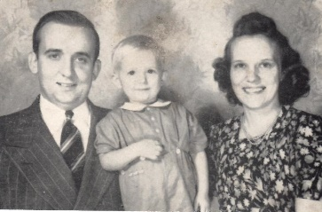

Janet, besides being a homemaker, taught Sunday School and Vacation Bible School. She also played piano and was in the string band.

Eight people were baptized while the Ankerbergs served at East Balsam. Pastor Burt remembers the church men bringing hot water from the creamery in milk cans to warm the water in the baptistry. On many occasions believers were baptized in the lake.

In October 1945, Joe Ankerberg (Burton’s father) and Howard Haney conducted special meetings that were so well-attended the meetings were moved to the High School Auditorium in Balsam Lake.

The decision was made in December 1945 to proceed with plans to construct a parsonage on the church lot. Additional land was given by Lawn Randall to enlarge the church lot.

In February 1946, Pastor Ankerberg concluded his ministry at East Balsam to accept a call to Montrose, South Dakota.

Both Burt and Janet have gone home to glory. Janet passed away August 4, 1984, after a three-month struggle with cancer. Burt suffered from post-polio syndrome. God released him from his crippled body on February 10, 1991.

**Howard & Mabel Olson**

**April 1946 – June 1949**

In April of 1946 a call was extended to Howard Olson who was about to graduate from Bethel Seminary. He was called to be an interim pastor but was soon extended a call to be full-time pastor.

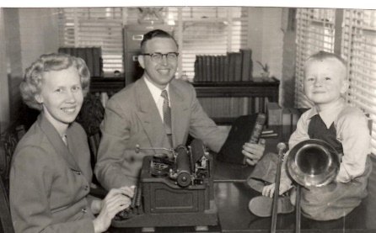

Howard and his wife Mabel “Mabs” lived in Carrie Solin’s house until the parsonage was built. The parsonage was completed in the summer of 1947. Pastor Olson’s father was able to help secure building materials, which were difficult to obtain following World War II.

Events during the Olson’s ministry at EBBC:

* August 1948 – Roger Youngquist held two weeks of meetings.
* October 1948 – The cement floor of the basement was waterproofed and covered with wood flooring.
* August 1949 – The church was closed for two weeks during the “polio epidemic”.

**Baptisms/Members—**Joan Fuller, Dorothy Ogren, Barbara Ogren, Juanita Michaelson, and Alexander Shattuck were baptized and became members. Other who joined the church by confession of faith were Clara Burch, Helen Shattuck, and Ann Richardson.

Pastor Olson enjoyed working with the youth. He was musical, played the trombone, and for a while directed the High School Band at the Balsam Lake School.

Mabs taught Sunday School, started a junior church, superintended the Primary Department, typed all of her husband’s correspondence, and assisted in the visitation ministry besides her homemaking duties.

“Adult Fellowship” meetings began during Pastor Olson’s ministry and continued for several years. Once a month “anyone who did not go to young peoples” met in homes for a program and refreshments.

Pastor Olson concluded his ministry to take up a pastorate in Mora, Minnesota, in June 1949.

The Olsons had one son, Richard Wayne (Ric). Both Howard and Mabs have gone to meet their Savior.

**Ray and Elaine Larson**

**June 1949 – July, 1953**

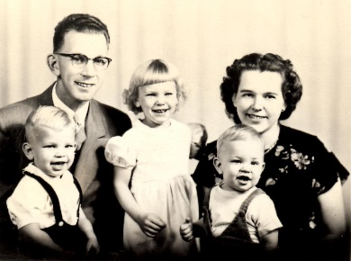The church again looked to Bethel Seminary for a new graduate and Raymond Larson with wife, Elaine, came to minister in June of 1949. Ray had been a student pastor in Cushing, Minnesota; a student missionary for the Wisconsin State Conference; and interim pastor at Mason, Wisconsin, before coming to Balsam Lake.

Three children were born during their stay at East Balsam – Esther Marie, David Allen, and Andrew Ray. Priscilla Kay joined the family later.

The church ordained Pastor Larson in October 1950. The services were conducted in his home church in Ashland, Wisconsin.

The mortgage on the church building with the Northern Convention was paid off and the occasion celebrated with a smorgasbord in October 1951. Pastor Larson and Mrs. Adolph Olson prepared a smorgasbord and served 140 people. Pastor Gordon Johnson was guest speaker. This mortgage had been held by the State Convention since 1910.

In August of 1952, the mortgage on the parsonage was renewed for two years with the goal to have it paid off by then.

During Ray Larson’s ministry, the church entry was remodeled, the church interior was redecorated, and the church entertained the Wisconsin State Conference in June of 1952 – a big undertaking for a small church. Pastor Larson liked to take on big projects and worked very hard to make them a success.

In November 1952, Oliver Omanson, pastor of the Amery church, came to speak for a series of special meetings.

Four members were received during his ministry – Daniel Michaelson and Melvin Ogren were baptized; Ray Bailey and Orra Holin joined the church by letter of transfer.

Pastor Larson concluded his ministry at East Balsam in July of 1953 and went to pastor a church at Estherville, Iowa. After serving churches at Stanchfield, Minnesota, and Trade Lake and Mason in Wisconsin, he owned and operated Christian bookstores in Braham, Minnesota, and Ashland, Wisconsin, as well as working for Larson Picture Framing Company. During his retirement, Pastor Ray was actively involved with the historical societies of Mason, Bayfield, and the State of Wisconsin. He enjoyed history and built a log house, chapel, and a tool shed museum on an island connected to their homestead on Indian Lake in northern Wisconsin. He loved to entertain and give history lessons to young and old alike.

Ray Larson became ill in the fall of 1999 and was diagnosed with lung cancer. He passed away on November 18, 2000. His wife Elaine has also passed away.

**Nels & Irene Nelson**

**September 1953 – September 1956**

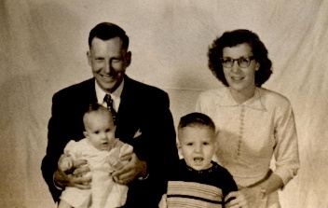

In September 1953, Nels A. Nelson with wife, Irene, son Daniel, and baby daughter Luann, moved into the parsonage to begin a three-year ministry with the church. Nels had graduated from Bethel Seminary in the spring.

September 1954 – Pastor Nelson officiated at his first wedding, that of David Michaelson and Joan Fuller.

October 1954 – EBBC celebrated the church’s 50th anniversary.

Other events which took place while Nels Nelson was our pastor:

* February – the upstairs of the parsonage was finished.
* June 1955 – Pastor Nelson was ordained in his home church in Oakland, Nebraska.

**Baptisms/Membership—**Velda Alen, Edith Hughes, and Darrel Alen were baptized and became members. Others who joined the church were Eunice Alen, Lester & Agnes Fuller, and Bob & Vergie Nelson.

The Nelsons have memories …

* Of sending helium filled balloons with Gospel tracts at VBS. A response came from Trego, WI.
* The times of fellowship enjoyed with the people and the life-long friendships made at that time.
* Special meetings when some were saved and others rededicated their lives to Christ.
* The Mission Circle putting on the program “Bride of Christ” when different ladies wore their own or their mother’s wedding dresses.

Besides her homemaking duties, Irene went calling with her husband, taught in the Sunday School, served on the Music Committee, and directed Daily Vacation Bible School.

After leaving East Balsam in September 1956, Nels pastored several churches. After retirement, they kept busy serving the Lord. Both Nels and Irene have gone home to be with the Lord.

**Rev. A. J. & Marie Hulbert**

**October 1956 – May 1964**

Both Pastor Hulbert and his wife Marie were born in Sweden. He pastored several churches and then served as the Wisconsin State Missionary from 1952-1956. He was almost retirement age when he accepted the call to East Balsam. They were familiar with the church and people in the area as they had a cottage on Bone Lake for many years.

Some of the events during Pastor Hulbert’s ministry at East Balsam were:

* 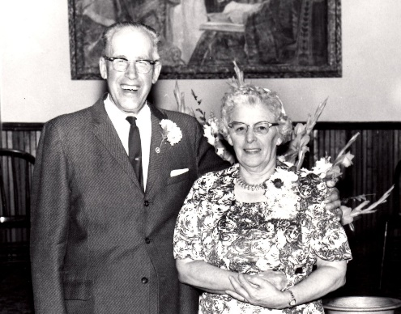November 1956—the wood furnace in church was replaced with a gas furnace.
* May 1957— “God’s Acre” project. Twenty-two acres of land was rented for $75 on which to plant sweet corn as a cash crop.
* July 1957—Tent meetings at Balsam Lake with Rev. Kingsley. Tent meetings in cooperation with other churches and various speakers continued annually for many years.
* November 1957—Special meetings with Rev. Ernest Rockstad.
* October 1958—Delegates attend a recognition service for a new Conference Church in Cumberland, Wisconsin. Pastor and Mrs. Hulbert and Joan Michaelson conducted a Vacation Bible School in Cumberland one summer. Others went with the Hulberts to conduct services on Sunday afternoons.
* October 1958—Special meetings with Dr. Divine.
* 1959—New entry with enclosed steps put on the church building.
* October 1960—Rev. Gordon Johnson from Wood Lake came to conduct special meetings.
* 1961—Irene Peterson volunteered one year of service in God’s Invasion Army – a group of young people dedicated to leading people to Christ through personal visitation and meetings. Irene met her husband, Paul Bailey, while serving in God’s Invasion Army. They were married December 8, 1961.
* October 1961—Rev. Russel Voight was speaker for special meetings.
* December 1961—New pews were installed to replace the old chairs.
* October 1962—Special meetings with Webster Muck.
* November 1963—An electric Lowery organ was installed in the church. The organ music added much to the worship service.

**Baptisms/Membership—**Richard Kreutzian, Nancy Hughes, Esther Michaelson, Ginger Ogilvie, Anna Lysne, Shirley Price, Rodney Kreutzian, Shelby Hughes, Bonnie Lou Hughes, Alfred Peterson, Gene Price, Mary Peterson, Harold Peterson, Ron Ogren, Iris Swanson, Jeanne Price, Craig Nelson, Larry Nelson, and Charles Duffert were baptized and became members. Others who joined the church were Don & Iris Nelson, Mrs. & Mrs. Archie Pearson, Cliff and Helga McClain, Agnes Kreutzian.

In March of 1964, Pastor Hulbert notified the church that he planned to retire May 1st after spending 50 years in the ministry. In May, a big reception was held at the church as a farewell and to celebrate his completion of 50 years of Gospel ministry. However, he did not retire, but at about age 70, went on to pastor churches at Cadott and Augusta, Wisconsin.

**Roland & Verna Christenson**

**June 1964 – September 1967**

June 1964 – Roland and Verna Christenson, with little daughters Jocelyn and Cheryl, moved into the parsonage. Son Leland joined the family while they were at East Balsam. Pastor Christenson had just graduated from Bethel Seminary.

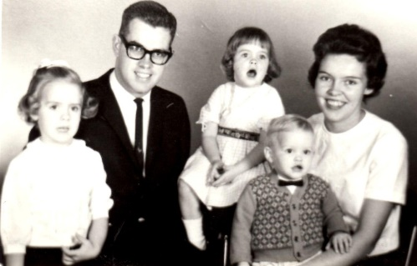Some of the events that took place while Roland and Verna ministered at East Balsam:

* October 1964 – Celebration of the church’s 60th anniversary. Carpeting of the platform and church aisle.
* November 1964 – Special meetings with Rev. William Gustafson
* July 1965 – The youth have a “slave auction” – hiring themselves out to do work to earn money for Young Peoples.
* November 1965 – the church entertains the council and ordination service for Pastor Christenson

**Baptism/Membership—**Julie Hughes, Delbert Hughes, Donald Peterson, Steve Volgren, Merry Volgren, David Kreutzian, Keith Alen, James Holin, Pam Moore, and Mary Ward were baptized and joined the church. Keith Ward joined the church by confession of faith.

The Christensons have special memories – “Our first wedding, first baptism, our introduction to country life (Roland was born in Muskegon, Michigan – Verna in Grand Rapids, Michigan), the big storm that blew six trees down in the yard, the times the car would not start in the cold weather (one time -53 degrees), the good Christian fellowship with members and friends.”

Verna, besides being busy as a wife and mother, organized and led Girl’s Missionary Guild, was assistant pianist and organist, played the flute, and taught in Sunday School and VBS.

Roland was pastor at several churches before being diagnosed with cancer and dying in July 1996. Verna was employed at the office of the Minnesota Baptist Conference.

**Gordon Johnson**

**Interim Pastor 1967-1968**

Rev. Gordon Johnson, Camp Director at Wood Lake Camp, consented to be our interim pastor. He came to preach each Sunday, but did not stay at the parsonage. His messages and counsel were very much appreciated.

* God’s Invasion Army spent some time here.
* February 1968 – Concert by the Swedish Family Singers.
* March 1968 – The parsonage kitchen was remodeled and new cupboards installed.
* Kathleen Holin was baptized and became a member. Mrs. Violet Ward became a member by profession of faith.

By 1968, regular church attendance combined with the attendance of summer visitors had so crowded the facilities that the decision was made to have two Sunday morning services from June 1st through Labor Day weekend. This practice continued until the church was enlarged in 1974.

**B. Wayne & Marge Johnson**

**June 1968 – November 1976**

B. Wayne Johnson, a native of Saskatchewan, Canada, newly graduated from Bethel, with his wife, the former Marjorie Hecker of Benson, Minnesota, began their ministry at East Balsam in June of 1968.

Activities during those years include:

* September 1968 – Joyce, Arelene, and Lois conducted special meetings.
* January 1969 – dedication of a new church piano.
* May 1970 – a new gas furnace was installed in the parsonage.
* November 1970 – Rev. Herbert Cannaday conducted special meetings teaching about cults.
* April 1972 – The church entertains the ordination council and service for Pastor Johnson. Concert by Ray Larson and his string band from Mason, Wisconsin. Pastor Johnson asked permission to be a substitute school bus driver.
* 1971 and 1972 – Kids meetings were conducted at Balsam Lake School instead of VBS at church.
* 1973 – Six High School young people formed a singing group calling themselves “The New Life Messengers”. The group included Keith Alen, Lois Alen, Doug Palmer, Pam Moore, Cindy Palmer, and Merry Volgren. They gave several concerts in the area and then won the Great Lakes District contest, which entitled them to compete at the General Conference in Wheaton, Illinois. Pastor Wayne and Marge accompanied them to Wheaton. On their return trip they met up with an accident, which could have been serious but fortunately was not, thanks to God’s protecting hand.
* 1974 – New hymnals were purchased.
* April 1975 – The church kitchen was remodeled and new cupboards installed.
* September 1975 – Redd Harper here for three evening meetings.
* October 1976 – Funeral for Cliff McClain.

**Baptisms/Membership—**Pam Holin, Lois Alen, Karen Volgren, Mike Volgren, LeRoy Michaelson, Dennis Kreutzian, Julie Renz, Cheryl Peterson, Bonnie Brihn, Kathy Brihn, Dale Holin, Susan Holin, Larry Michaelson, Carol Jean Michaelson, and Star Minke were baptized and joined the church. Others who joined the church through confession of faith were Kent and Cheryl Stock, Grace Alen, Tom Cole, Howard and Elaine Palmer, Doug Palmer, Shirley Palmer, Al and Marion DeLong, Rick and Joyce Highstrom, Don and Iris Nelson, Neil Nelson, Dean Nelson, Donna Nelson, Gail Nelson, Gini Ogren, Lawrence and Renaye Johnson, Terry Palmer, Sandy Palmer, Jerry and Marie Blair, Marvin and Lila Nelson, and Sandy Hunter.

During their stay two children were born – Jennifer Joah and Ellick Egan. Karla Kris joined the family while they were in Ashland.

In September of 1976 Pastor Wayne read his letter of resignation, having accepted a call to be pastor of Salem Baptist Church, Ashland, Wisconsin. The church entertained a dinner and farewell service the afternoon of November 14, 1976. Many tears were shed as the congregation said “goodbye”.

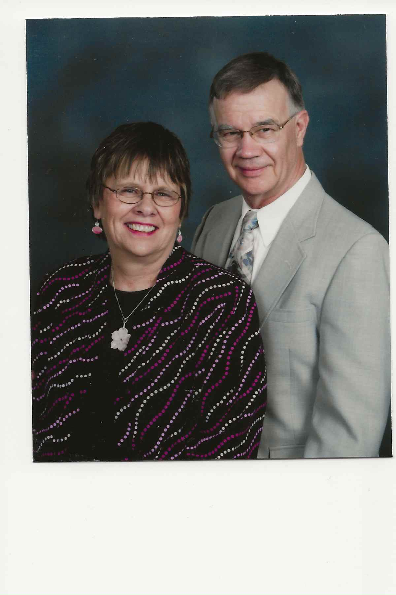

**UPDATE FROM WAYNE—September, 2019**

“We arrived at East Balsam Baptist Church the day after Wayne graduated from Bethel Seminary. Our last days pastoring at the church were in October 1976. Our experience with the wonderful folk of EBBC was a gift from God. Our last official role was, sadly, officiating at the funeral of long time EBBC member Cliff McClain.

“Our pastoral work began immediately after in Ashland WI, and continued until 1985. Again, we had wonderful experiences there, gaining even more precious friends. Our daughter Karla was born there. And we had the privilege of building a new church structure.

“Our next move found us in the northern suburb of Coon Rapids in the Twin Cities area. We soon bought a small house with a big yard, where we still reside. We worked hard at developing our yard into a floral display. Marge loved to plant flowers, and Wayne was happy to weed flower beds.

“Marge providentially secured a teaching position in the northern suburbs, and Wayne worked on some computer training. He eventually found a job with IDS Financial Services, where he worked until his retirement in 2006. Marge retired in June of 2007. She immediately ventured out bravely to fill in for a maternity leave at a missionary school in Budapest, Hungary. It was a profoundly satisfying experience for her. I also traveled on mission trips, going to Ukraine five times. Some of those visits were to work with a small community of believers near Kharkov, and others to teach courses at a small Bible school in Kiev.

“We quickly found a thriving church here, Coon Rapids Evangelical Free church. The fact that the church had a strong youth program was attractive to us. Our family grew and part of them eventually moved away – Ellick into the Air Force and then to Colorado where he married, Karla married and moved to the Los Angeles area. Daughter Jenny stayed close by us.

“Both Marge and I became active in church activities. Marge took on various roles including serving on the worship team for a few years. I continued my love of Bible teaching by sharing with adult classes on Sunday mornings.

“God has provided for us marvelously over the years – with good friends, adequate employment, good health and spiritual growth.”

**Merrill & Jan Olson**

**December 1976 – June 1981**

In December of 1976 Merrill Olson, a senior at Bethel Seminary, consented to come out every weekend to serve as interim pastor. The church soon extended their call to Pastor Olson. He and his wife Jan started full-time on June 1, 1977.

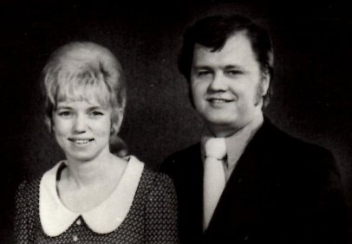

Merrill Olson graduated from Mankato State University, taught school a few years, and spent some time in military service, then felt the call to become a pastor. Merrill was born in Slayton, Minnesota. Jan grew up in northern Minnesota. They were married in the chapel at Northwestern College in Roseville on December 12, 1973. A son Matthew was stillborn in June of 1977. They later adopted two Korean daughters – Angela and Bethany.

The church entertained an ordination council for Pastor Olson on August 21, 1978, with an ordination service on September 2, 1978.

Jan served in many ways – librarian, Sunday School and VBS teacher, led Bible studies for the women and youth, typed the bulletin and church correspondence, helped with junior church, and went visiting with her husband.

Activities during the Olson’s ministry at East Balsam include:

**Baptisms/Membership:** Carol Beauvais, Pat Cahill, Kenneth Mosay, Delores Mosay, Karrie Mosay, Debbie Grim, Debbie Cox, Kathy Highstrom, Amy Highstrom, Jimmy Hughes, Rick Osborn, and Jamie Johnson were baptized and became members. Others who joined by confession of faith were Ben and Jewell Eklo, Rebecca Moore, Bess Pearson, Dave Hemingway, Cheryl Volgren, Norval and Pat Valleen, Mike Volgren, Don and Harriet Grim, Ernest and Mary Hall, Sally Coyner, Tom Anderson, Marye Anderson, and Debbie Johannsen.

* August 1977 – The Lundstroms conducted a crusade in Amery, Wisconsin.
* March 1978 – The Palermos put on a “Spaghetti Spectacular”.
* New pulpit and platform furniture purchased. The old pulpit, purchased for $27, had been used since 1912.
* June 1978 – There is rejoicing as the indebtedness on the church building is paid off.
* September 1978 – A library corner was built in the church basement. Jan Olson did an excellent job of cataloging and arranging the books.
* October-November – paneling and ceiling tiles were installed in the old part of the church basement
* January 1979 – The church auditorium was painted.
* October 1979 – The church celebrated its 75th anniversary.
* October 1980 – Special meetings with Peter Todd.
* February 1981 – A Missions Committee was formed consisting of five members.
* March 1981 – A new Baldwin Chapel Organ was purchased.

Early in 1980 it was felt there was a need for larger facilities – more seating space, the foyer was too small, the parking area was too small, and there was not enough room for Sunday School classes. There was much discussion as well as consultations with builders as to whether a new building should be built on another site or to expand the present facilities. In November, it was recommended that the church begin a building program on a new site but the recommendation was voted down. A building committee was appointed to study alternatives. In 1981, the nursery was moved to the basement and a wall removed, thus enlarging the church foyer.

Pastor Merrill read his letter of resignation to be effective on June 21, 1981.

**Events while church was without a pastor following Olsons—**

* In June of 1981, a van was purchased to transport Sunday School pupils and the youth for special activities.
* Dennis and Carolyn Teschendorf and Al Holmgren were baptized and joined the church in June of 1981; Debi Nelson became a member in August.
* Funeral for Anna Lysne in 1981.

Merrill and Jan have been retired for several years, but keep busy in the Lord’s work. Merrill has served as interim pastor and filling a pulpit when some church has a need.

**Paul & Ruth Lundgren**

**Interim Pastor – September 1981—January 1982**

In October 1981, Rev. Paul Lundgren of Cambridge, Minnesota, came to serve as interim pastor until January 3, 1982.

At Pastor Lundgren’s suggestion, a Christian Education Board was organized in December of 1981.

Paul Lundgren was a graduate of Bethel College and Seminary. After pastoring churches at Mora, Minnesota, and Albin, Wyoming, he served as Field Missionary for the Great Plains District Conference for 21 years. Upon retiring from that position, he served as interim pastor at several churches. In October of 1985, he was called to work with Senior Adults at his home church, First Baptist of Cambridge, Minnesota; a position he held for over 15 years.

**Bruce and Ginger Tanner**

**January 1982 – October 1988**

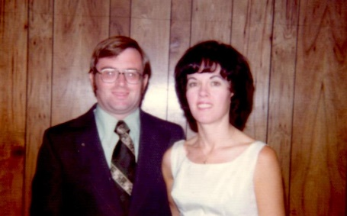Rev. Bruce Tanner and his wife, Ginger, began their ministry at East Balsam in January of 1982. They moved from Michigan in a snowstorm. Their belongings were unloaded at the parsonage but nothing was in order so they spent the night at the home of David and Joan Michaelson. It was several days before they could get their car started because the weather turned bitterly cold.

Pastor Tanner grew up in the Amery, Wisconsin, area, graduated from St. Paul Bible College, and attended Bethel Seminary for one year. In 1975 he married Virginia (Ginger) Gustafson and became stepfather to two sons, Scott and Garrie.

Highlights of their ministry at East Balsam:

**Baptisms/Membership—**Eric Holmgren, Allan “Skip” Holmgren, Linda Boileau, Roxanne Boileau, Tony Boileau, Michelle Boileau, Chris Boileau, Stephanie Alen, Matt Boileau, Glen and Claudine Brown, Candice Brown, Holly Mosay, Terry Christenson, Rochelle Alen, Leslie Ogren, Debbie Reinholz, Bethany Volgren, Roger and Marilyn DeSpiegelaere, Peggy Meyers, Chris Mitler, Krista Ogren, Erik Ogren, Roxanne Osborn, Don and Julie Bethke, Sally Bethke, David Teschendorf, Karen Brown, Cherie Brown, Laura Brown, Ryan Alen, Dawn Clark, Ricky Teschendorf, and Jenny Teschendorf. Other people who became members by confession of faith were Lettie Martin, Art and Ruth Mattson, Lisa Christenson, Robert Nepple, Nicole Hongerholt and children—Nathan, Danielle and Jamie Hongerholt, and Jerry and Brenda Paulson.

**Funerals:** Scott Holmgren, and Lillian Hughes (1982), Rudolph Richardson, Carl Swanson, and Lettie Martin (1983), Everett Johnston (1985), Geneva Ogren (1986), Edith Arvidson, and Carl Nelson (1987), Agnes Fuller (1988).

* July 1982 – The decision was made to build a Sunday School Annex which gave space for four classrooms.
* September 1982 – Pioneer Club, a program for children, was started at Unity School. Joyce Highstrom was coordinator.
* January 1983 – Began printing a monthly newsletter; Eunice Alen was editor and Joan Michaelson printer.
* Pastor Paul Lundgren had recommended that the church start a new work in the area rather than enlarge our local facilities. In February 1983, meetings were begun in the high school at Luck with a congregation of 25 to 30 people. Howard and Elaine Palmer, the Rick Highstrom family, Al Holmgren, and Ernie and Mary Hall left our congregation to form a core group for the new church in Luck. Pastor Tanner would preach at both churches on Sunday morning until May 1985.
* May 1983 – The Faith Baptist Church of Luck was incorporated with 15 members.
* July 1984 – Faith Baptist Church was recognized by the Great Lakes Conference at a special service. In September the Luck Church purchased a two-acre lot with a building on Highway 35.
* Special meetings with Rev. Carl “Cully” Olson.
* September 1985 – “Kids Klub” meetings were held at church rather than at the school; Lois Hemingway, coordinator.
* Fall 1987 – The church purchases material and furnishes labor for an extensive remodeling project on Cabin #7 at Wood Lake Camp.
* Fall 1987 to Spring 1989 – Church takes on an extensive remodeling of the parsonage.

September 1988 – Pastor Tanner submitted his resignation to be effective October 15th.

Pastor Tanner gave this update in 2019—

“We left EBBC in 1988, to accept a call to Calvary Baptist in Negaunee, Michigan. In 2001, we moved back to Wisconsin to serve Apple River Community Church.  I retired in 2013, but was soon recruited by Apple River to serve as visitation pastor. I currently preach two Sundays each month at Hope Bible Church near Luck, and do pulpit fill work in the area.  We purchased a small home in Niagara, Wisconsin, which is close to our Upper Michigan family.  We enjoy spending time up there when we can.  In past years, I have served as Hospice Chaplain in Michigan, and also here in Wisconsin.  I also wrote Sunday School material for Union Gospel Press for many years.”

Bruce and Ginger Tanner reside in their home in rural Clayton, Wisconsin. Bruce is currently filling the pulpit at EBBC part-time while the church is without a pastor in 2019.

**Pulpit supply while without a pastor** – During the time between Bruce Tanner and Ben McEachern, several people filled the pulpit. Those who came quite regularly were Paul Larson, a layman from Mason, Wisconsin, Orville Falk, a retired pastor who lived in Luck, Wisconsin, and former pastor, B. Wayne Johnson.

**Ben and Teri McEachern**

**June 1989 – May 1997**

In June of 1989, Ben McEachern, along with his wife Teri, son Caleb, and daughter Kalla, moved into the parsonage to begin their ministry at East Balsam. In 1992 another son, Grant, joined the family.

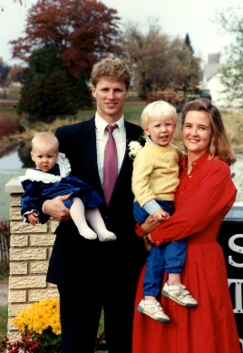

Ben is the son of a General Conference pastor and was born in Niagara Falls, NY. He spent his “growing up” years in Michigan and Minnesota. Teri (nee Sension) grew up in the Lake Minnetonka area and was married to Ben in 1984. Ben and Teri both graduated from Bethel College. Teri taught school for six years. Ben, after two years of selling real estate, went on to graduate from Seminary with a Master of Divinity degree.

Some of the events during Pastor Ben’s ministry at EBBC:

* October 15, 1989 – The church celebrates its 85th anniversary.
* Ben and Teri take Senior High Youth to Boundary Waters in Minnesota.
* June 23, 1991 – Dedication of the new church building for Faith Baptist Church of Luck – one of our daughter churches.
* The church “adopted” a second cabin at Wood Lake Camp in 1992.
* October 5, 1992 – Ordination Council for Pastor Ben McEachern.
* July 26, 1992 – Commissioning service for Steve and Carol Jean Gallagher who are leaving for Papua New Guinea to serve as translators under Wycliffe Bible Translators.
* May 23, 1993 – Church decides to move parsonage to a new location one-half mile south of the church; it was moved July 26, 1994.
* June 1994 – The first year a combined Vacation Bible School was held at Faith Lutheran Church in Balsam Lake. Later Faith Lutheran and Balsam Lake Methodist joined East Balsam.
* Nursery enlarged, painted, new carpet and furniture. Baptistry lined with plastic and water heater purchased.
* October 1995 – The church called Doug Schmidt to be Youth Pastor, however, after several months he realized this was not what God wanted him to do.
* September 22, 1996 – The church voted unanimously to erect a new house for Val Rowe; she moved in March 28, 1997. It was called “The House that Love Built”.
* April 13, 1997 – Pastor Ben reads his letter of resignation; a farewell service was held on May 11th.

**Marriages:** 1989—Carol Jean Michaelson and Steve Gallagher, Karen Brown and Dan Dahlman; 1992—Larry Michaelson and Barbara Wicklund, Tad Wilson and Michelle Boileau; 1994—Jeremy Schadow and Kris Krenz, Keith Alen and Marla Wheeler; 1997—Leslie Ogren and James Carlson, Glen Brown, Jr. and Debrielle Smith.

**Baptisms:** Pastor Ben performs his first baptism at EBBC as Rachel Hemingway is immersed in Balsam Lake. Others who followed the Lord in baptism were: Heather Ogren, Heidi Nutter, Jeremy Hoehne, Jessica McLellan, Tom and Linette Horn, Vern and Bonnie Williamson, Becky Swanson, Mark Bowen, Jeremy Schadow, Kris Krenz, Barb Bremer, Maxine and Steve Florer, Phil and Pam Stratmoen, Bethany Bowen, Glen Brown Jr., Caleb McEachern, Kim Gustafson, Jim & Kris Radke, Andrew Saterdalen, Alyssa Hemingway, Joshua Williamson, Olivia Florer, Kalla McEachern, Kaija Stratmoen, Dave Bibeau, and Amanda Sampson.

**New Members:** Roger and Vickie Peterson, Brad Peterson, Brian Peterson, Michael and Coral Bowen, Brad and Lynne Peterson, Steve and Anita Bont, Gary and Mary Nelson, Terry and Leann Palmer, Angela Palmer, Jeff Paxton, Terry and Angela Snider, Gordon and Rosette Palmer, Michael Smith, Brian and Ruth Matson, Gary and Jill Nelson, Bill and Florence McEachern.

**Memorial Services:** Don Majeske, Sally Coyner, Rebecca Moore, Marlys Burton, Gertie Nelson, Al and Marion DeLong, Olga Michaelson, Art Mattson, Murville Ogilvie.

During their ministry at East Balsam, they had the inconvenience of having to move out of the parsonage as the building was moved to the new location. Also, Teri experienced severe health problems, and eventually had a defibrillator implanted in her chest.

When Ben and Teri left EBBC, they went to Woodridge Church in Medina, MN, where he served as Associate Teaching Pastor and Small Group Director. In January 2000, they started North Ridge Fellowship in Rogers, Minnesota, where Ben continues as the pastor.

**Events while without a pastor after Ben McEachern resigned:**

* Wayne Johnson consented to be our interim pastor.
* In November 1997, the decision was made to purchase a digital piano.
* Deb Brown became a member.

**David & Tanni Sollitt**

**January 1998 to September 2010**

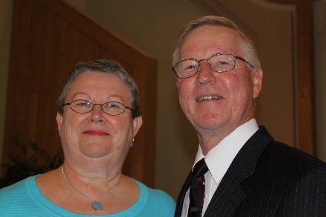David Sollitt received a B.S. degree from Michigan State University and a M. Div. degree from Bethel Seminary. He was ordained on April 16, 1984, at First Baptist Church, Dannebrog, NE. His wife is Tannette (Tanni) and his daughters are Kristin Thomas (husband Mark) and Keri Sollitt. Pastor Dave pastored three churches prior to coming to East Balsam.

Over the years Tanni, worked with Women’s ministries, Bible studies, VBS, Sunday School, and Pioneer Girls.

Events while Pastor Dave was at EBBC:

* At the May 20, 1998, Annual Meeting, a Facility Expansion Committee was chosen to determine if there was a need for a new church building; a Building Committee was formed in November 1998.
* At the Annual Meeting on May 17, 2000, it was voted to build a new church. There had been talk of the need back in the 1980s, but the Lord’s timing was 20 years later.
* Due to failing health, Eunice Alen resigned as Church Historian in 2001. She had served for many years and prepared the 75th Anniversary book.
* Bruce and Candice Beatham were preparing to serve with Wycliffe Bible translators. They left for Costa Rica to attend language school August 20, 2001. On August 25, 2002, Bruce and Candice Beatham were commissioned for service in Mexico.
* October 7, 2001, was the groundbreaking for new church on the church’s 97th anniversary.
* The first photo directory for EBBC was published in 2002.
* The first Community Good Friday Service at Faith Lutheran in Balsam Lake, which included Faith Lutheran, Trinity Methodist, and East Balsam Baptist Churches.
* October 6, 2002, was the last service in the old building and first in the new one.
* A church auction was held on October 26, 2002, to sell pews and items donated for sale.
* The old church building was sold to David and Heather Tiedemann on October 31, 2002. The Tiedemanns later sold the building and the buyer made it into a lovely home. Open house to see the remodeled building was held January 12, 2003.
* The new church building dedication was held June 8, 2003.
* Bruce and Candice Beatham move to Coicoyán, Mexico, to begin learning the language and translating the Bible into Mixtec.
* Chuck Knapp of KTIS gave his testimony on May 29, 2004.
* October 2 & 3—celebrated the church’s 100th anniversary. Former pastors and wives (or widows) in attendance were: Howard and Mabel Olson, Merrill and Jan Olson, Elaine Larson, Bruce Tanner, as well as Stan and Lillian Rendahl, who filled the pulpit many Sundays around 1940.
* February 9, 2005, Irvin Alen submitted his resignation as usher after serving 54 years.
* December 2005, Church newsletter discontinued after 23 years. It was started again in May 2009.

**Baptisms:** Ed Anderson, Justin Nelson, Nathan Nelson, Leah Stratmoen, Brian Mabry, LeRoy and Joyce Brown, Michelle Becker, Peter Matson, Romni Matson, Katie Radke, Kelley Radke, Adam Majeske, Marion Majeske, Penny Majeske, Erin Mabry, Drew Matson, Clinton Holin, Nick Becker, Erin Gallagher, Karen Ogren, Erv Moe, Sanay Hemingway, Nicole Majeske, Logan Triebold, Leta Triebold, Carly Holin, Jordan Rice, Amanda Johnson, Steve Reed, Kelsey Johnson, Steve and Polly Miller, Dawn Michaelson, Pat Davis, Eric Priebe, and Gail McKenzie.

**Weddings:**  Paul Alen and Pearl Johnson (1999); David Tiedemann and Heather Ogren (2000); Matt Larson and Rachel Hemingway—at Brooklyn Park, MN; Myrko Balaban and Rochelle Alen—in Nevada (2001); Ray Ogren and Karen Bergh—in Iowa; Richard Weldt and Charity Alen—at Northwestern College; Brett Hansen and Krista Ogren—first wedding in the new church building (2002); Erik Ogren and Amber Fasbender (2003); Adam Majeske and Nicole Fox (2004); Rebecca (Becky) Swanson and Esden Brunette (2005); Gary Nelson and Theresa Mattson (2007); Sarah Priebe and Ryan Hanson (2008)

**Funerals:** Lola Alen, Marvin Nelson, Nancy Ogilvie, Paul Alen, Florence Hughes, Dick and Jessie McClain, Betty Ogren, Dave Bibeau, Victor Holin, Penny Majeske, Robert Holin, Agnes Kreutzian, Pearl Alen, Vergie Nelson, Ruth Mattson, Ray Ogren, Barbara Palmberg, Jill Nelson, Bill Osborn, Sheila Mosay, Sanay Hemingway, Doug McKenzie, Carl Volgren, and Helga McClain—age 104.

**Note:** Former members and summer visitors who passed away: Howard and Mabel Olson, Gertrude Neslund at age 105, Harold Peterson, Joe Carpenter, and Cheryl (Alen) Stock.

**Move to the new building:**

On October 6, 2002, the last service in the old building and first service in the new one took place. At 10:00 a.m., the Worship service was begun in the old building. Pastor Dave Sollitt talked about our great heritage, and asked for a show of hands of how many had been married in the old church building and who had been baptized there. The men’s quartet sang *Blest Be the Tie That Binds*. The pulpit was loaded 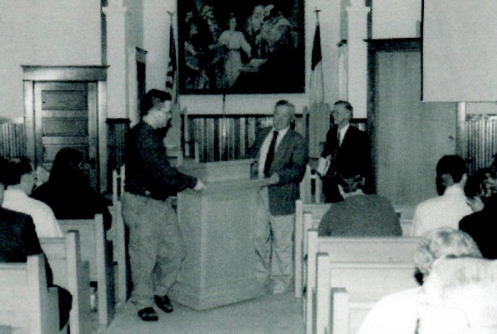onto a pickup (piano and organ had already been moved), people took the hymnals, and a caravan drove to the new building.

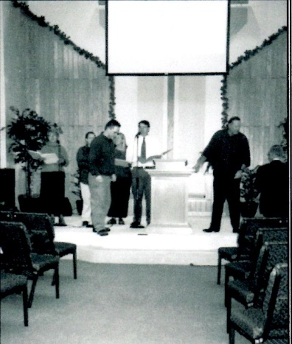As the congregation walked in, the Worship Team was singing praise songs accompanied by the organist and pianist.

Leslie Carlson sang two songs, one of which had these words: *May this be a place filled with praise and may every heart and voice be raised … and most of all we’ll thank Him for Jesus Christ His only Son.*

Pastor Dave’s message was from Colossians 4:2-6, *“Devote yourselves to prayer, being watchful and thankful. And pray for us, too, that God may open a door for our message, so that we may proclaim the mystery of Christ … Pray that I may proclaim it clearly, as I should … make the most of every opportunity ….”* His challenge was to be watchful (1) for opportunities (2) against the devil’s schemes (3) for answers to prayer, and (4) to use the open doors that God gives to proclaim the Gospel of Christ.

The morning service culminated with Keri Sollitt singing *Find Us Faithful.*

**Up-date:** Dave and Tanni were asked for an update of what they are doing at this time (September 2019). These are their responses:

**Tanni: “**As we are now retired, our lives are less structured overall.  Of course, it is a great joy for us to live within 15 - 20 minutes drive of both of our daughters!   A couple of activities that we enjoy doing are volunteering in our daughter’s first grade classroom once a week and helping with a monthly worship service at a retirement residence.

“Something that the Lord has led me to is facilitating a women’s weekly Bible study at our church.  I spent all of my years as a pastor’s wife working with children, so this was a new and unexpected challenge!  It has been very rewarding.  We have also enjoyed some international travel and have particularly enjoyed visiting locations where Paul ministered.”

**Pastor Dave:** “Tanni has shared some of what we are up to.  I lead a men’s Bible study at the same time she is working with the women.  I unretired for about a year to serve as interim pastor in our church.  And I fill the pulpit some of the times when our pastor is gone.   Tanni mentioned our travels, which have been a real pleasure and educational experience.  Some Biblical places have included Rome, Athens, Corinth, Thessalonica, Philippi, Berea, Ephesus, and Patmos.  A year from now we are hosting a group on a trip to the Holy Land and to the Passion Play in Oberammergau, Germany.”

**Between Pastor Sollitt and Pastor Gabe:**

* Many speakers filled the pulpit while we were without a pastor from September 30, 2010 to October 2, 2011. Missionaries, John & Lori DeCleene and Steve & Carol Jean Gallagher shared their work with us. Adam Gallagher shared what it is like being a MK (Missionary Kid) and played his saxophone.
* Services were cancelled on November 14th and 21st because of the weather.
* “Christmas Comes to Lonestar Gulch” was presented on the morning of December 19th. James Carlson provided a pancake brunch.
* December 24th—Christmas Eve Service at 4:00 p.m. Supper was served at 5:30 for anyone who would otherwise have to eat alone.
* Various times of food and fellowship were enjoyed—WII Bowling Tournament, SOUP-ER BOWL party, and Crappie Fishing Workshop and Pancake Breakfast.
* August 2011—Pat Thull baptized and joined the church.

**Deaths:** Edith Peterson, Lois Hemingway, Joleen Jensen, and Quinton Brunette, 2-month-old son of Esden & Becky Brunette.

**Gabriel (Gabe) and Melonie Brennan**

**October 2011 to June 2019**

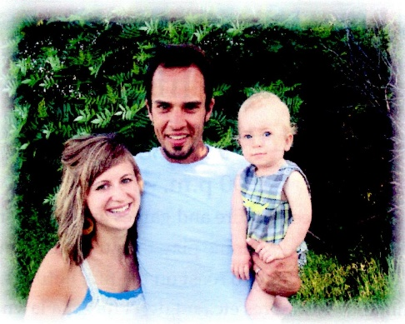Gabriel (Gabe) Brennan and his wife, Melonie, grew up about 30 miles from each other in the Brainerd, Minnesota area.  They did not meet until Gabe was 24 and Melonie was 20. Gabe was a senior at Moody Bible Institute and Melonie was a full-time nurse at Hudson Hospital. They met through mutual friends. Melonie attended Central Lakes College in Brainerd, Minnesota, and graduated as a Registered Nurse in 2006.  Gabe graduated from Moody Bible Institute with a BA in Bible.

**THEN**

**October 2011**

After graduating from Moody in the spring of 2007, Gabe and Melonie got married in December. He then attended Bethel Seminary and graduated with an M-Div with a concentration in Marriage and Family Studies in the spring/summer of 2011.

Pastor Gabe’s first Sunday was October 2, 2011, one year and two days after Pastor Sollitt’s last Sunday at EBBC.

**Events while Gabe was Pastor:**

* July 2012—EBBC had a float in Balsam Lake parade.
* 2015—Cheryl and Bethany Volgren put together a church directory in loose-leaf notebooks.
* June 2015—Remodeling of nursery and painting of church begun.
* June 2015—Men hosted a Manhood Breakfast. Participating churches: Apple River Community, First Baptist-Amery, East Lincoln Christian Missionary/Alliance, EBBC.
* July 2015—The Durocher’s Live, a family group put on an inspiring musical program.
* September 2015—Music with a Message by the Hartley Family followed by Kim Hilleshiem’s testimony of how God changed her life.
* October 2015—Dinner and Movie Night. Adults watched “Do You Believe?” and Kids watched “The Lion of Judah”.
* October 2015—Installation of new playground equipment began.
* November 2016—Packed 120 Operation Christmas Child boxes.
* February 2017—New piano purchased to replace the one we had for 20 years.
* Helping Hands organized to help people in church and community.
* An offering of $2,227 received to help victims of Hurricane Harvey; money was donated through Samaritan’s Purse.
* October 2017—Children’s Service Sunday (CSS). Children helped with the worship and fellowship time. Several CSS days held about once a year.
* November 2017—Sarah Bowers, Taylor Lund, Anna O’Brien, and Hallie Richter left for a Mission trip in Hatti.
* March 3, 2018—Night of Praise and Worship organized by Anna O’Brien.
* June 2, 2018—Adults and Children traveled to Coon Rapids to help package food for “Feed My Starving Children”.
* A CANVAS PAINTING FUNDRAISER was held at church to raise funds for the Community Referral Agency (CRA). CRA is a local domestic and sexual violence shelter in Milltown. Over $300 was raised.
* 2018—Money collected to purchase a new van for Val Rowe. Her old one had been rear-ended.
* November 2018—packed 225 shoe boxes for Samaritan’s Purse.
* April 13, 2019—Outreach Event—music by Glory Train and Kim Hilleshiem gave her testimony of life when she thought she was going crazy, and how it changed after she asked Jesus into her life.

**Baptisms:** Scott Anderson, Walter Rodke, Dale Michaelson, Maggie Conlan, Karolyn & Tony Worrell, Jerad & Krista Moe, John & Jackie Larson, Joshua & Jessica Cramlet, Joy Barthman, Sarah Broome, Sydney Volgren, Gideon Schmidt, Beckett Schmidt, and Anna O’Brien.

**Weddings:** Erin Mabry and Logan Hilleshiem (2016); David Richter and LaVonne Downing (2017).

**Funerals:** Lila Nelson, Eunice Alen, and Charlotte Rosenberg (2012); Orra Holin, Walter Rodke, and Al Taylor (2014); Irvin Alen, Ethan Michaelson, and Julie Richter (2015); Marion Majeske (2017); Shirley McClain Duffert (2018); Chuck Steege (2019).

**NOTE:** Our church was used for funerals of Howard and Elaine Palmer (2013) and Ellery Davis, members of Faith Fellowship in Luck (2014). Former pastor and wife, Nels and Irene Nelson both passed away in October of 2013. Bill Stewart, summer visitor (2015); Karen Carpenter, summer visitor for 30+ years (2016); Don Jensen’s daughter, Debra, passed away in 2019, eight years to the day after Don’s wife Jolene died.

**PASTOR GABE RESIGNS—FAREWELL TO PASTOR GABE, MELONIE, & FAMILY**

Following the morning service on June 9th, Pastor Gabe asked the congregation to be seated as he had an announcement to make.

He started by saying, in 2011 he became the pastor at EBBC. He and Melonie had one child, and this was the first church he pastored. Now their family has increased to four boys—Jude, Jonah, Clive, and Reeve.

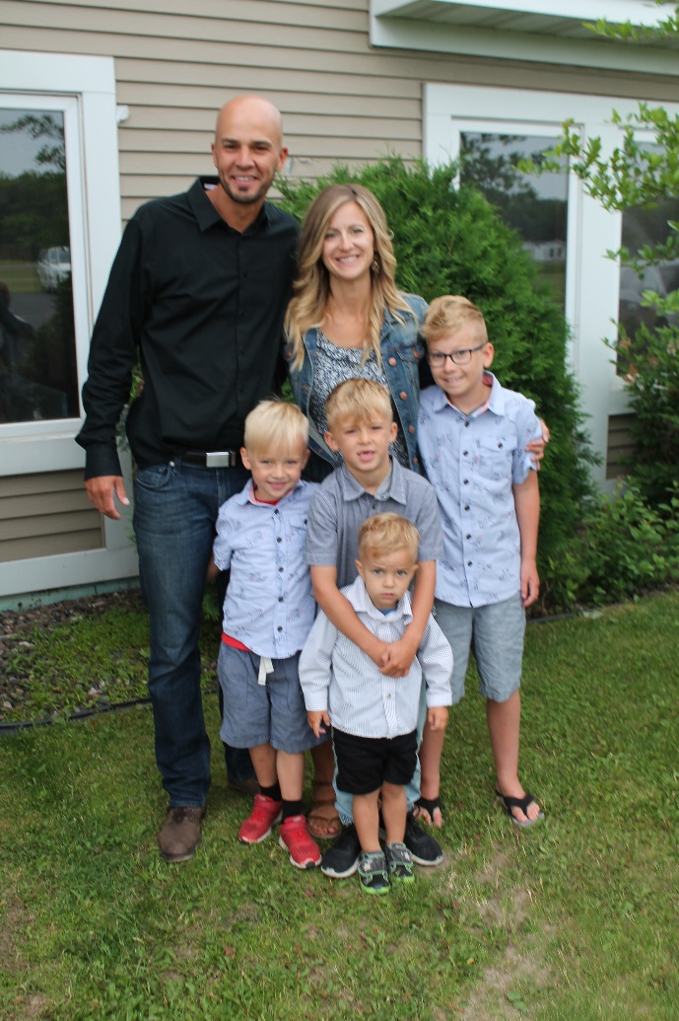Pastor Gabe gave his first sermon on October 2, 2011. Before Pastor Gabe came, we hardly had enough children to have a Sunday School class. Now, when the announcement is made for Children’s Church, there is a “grand exodus”. We are thankful for the young families who realize the importance of bringing their children to church.

Pastor Gabe was going to take a three-month sabbatical, but they believe God is leading them on to some other place; they don’t know where that will be. It was a hard decision as they have made many friends at EBBC.

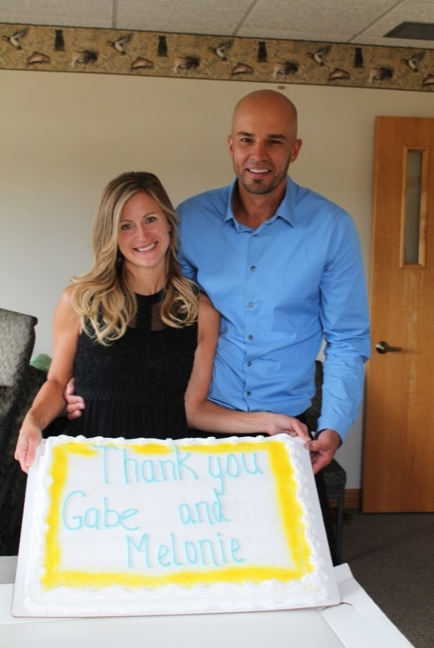

Their last Sunday at EBBC was June 30th. After the morning service, we had a potluck meal followed by a farewell service at 11:30. Cake and ice cream were served after the farewell service which allowed a time to visit and say our good-byes.

**NOW**

**June 2019**

In September of 2019, Gabe reported, “We are doing well and getting settled into White Bear Lake for a time. We are still exploring opportunities for future ministry and are trusting the Lord with next steps. We had a nice summer of resting and spending time together as a family!”

The cake says

“Thank you, Gabe and Melonie”

**East Balsam has been “First Church” for many Pastors at EBBC—**East Balsam has been the “first church” for nine young pastors, and the church has prospered through the years under their ministries. So, it would be at “East Balsam” that they would officiate at their first weddings and perform their first baptisms. It seems that part of the church’s ministry has been to help newly graduated pastors get experience in their chosen profession.

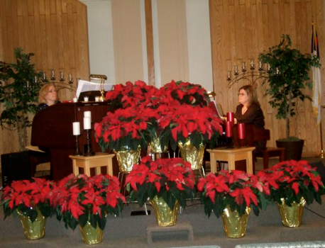

**Christmas Concert**

Lois Hemingway & Vickie Peterson provided us with beautiful Christmas music in Caroling for Christmas for about ten years.

**Missionaries**

Three young ladies who grew up attending East Balsam Baptist Church, along with their husbands, became foreign missionaries.

**Kent and Cheryl (Alen) Stock—World Vision**

In 1983 Cheryl and Kent moved to California to join World Vision. Cheryl passed away in November 2009. Kent continues to live in Washington state but is no longer involved with World Vision. They had two daughters, Christine and Sarah.

**Steve and Carol Jean (Michaelson) Gallagher**

**Wycliffe Bible Translators in Papua New Guinea**

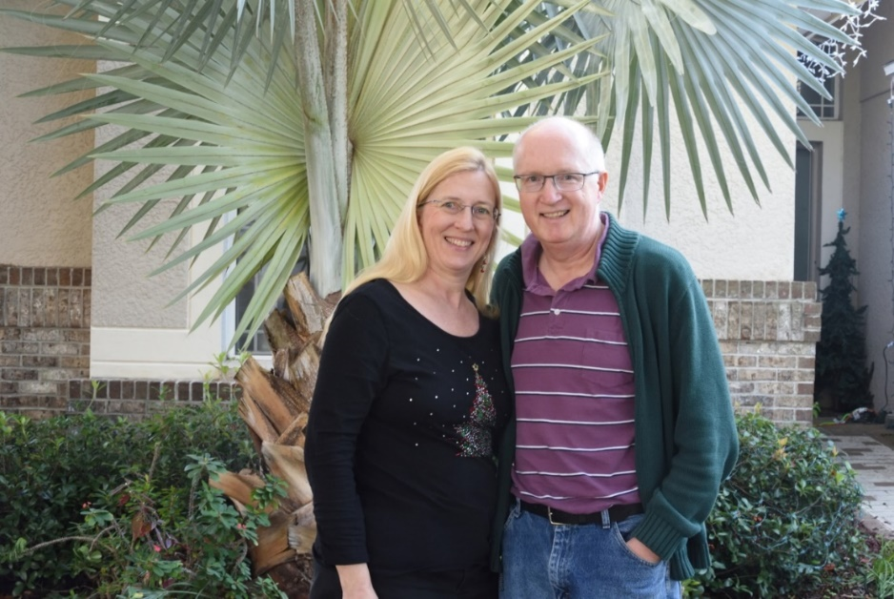

Carol Jean Gallagher grew up at EBBC. (She is the daughter of David & Joan Michaelson.) Steve and Carol Jean have been working in the ministry of Bible translation in Papua New Guinea since 1992. After working among the Bariai people for twenty years, they and their Bariai teammates reached the goal of completing the Bariai New Testament with Genesis and Exodus, which is available in both written and audio form. For the next five years, the Gallaghers continued to train and encourage people to engage with and apply the Scriptures to their lives. Since 2017, Steve has been serving as a full-time translation consultant for on-going translation projects in PNG. Carol Jean taught second grade at the mission center’s international school.

After much thought and prayer, the Gallaghers are relocating their base of ministry from Papua New Guinea to Florida. Steve will continue to work as a translation consultant, serving translation teams in PNG and other Pacific countries. He will work remotely on consultant preparation and will travel to the Pacific for face-to-face consultations a couple of times a year. Carol Jean is planning to join the Wycliffe recruitment team as an administrative assistant. She looks forward to helping recruit the next generation of missionaries who will serve in the work of Bible translation.

**Bruce and Candice (Brown) Beatham**

**Wycliffe Bible Translators in Mexico**

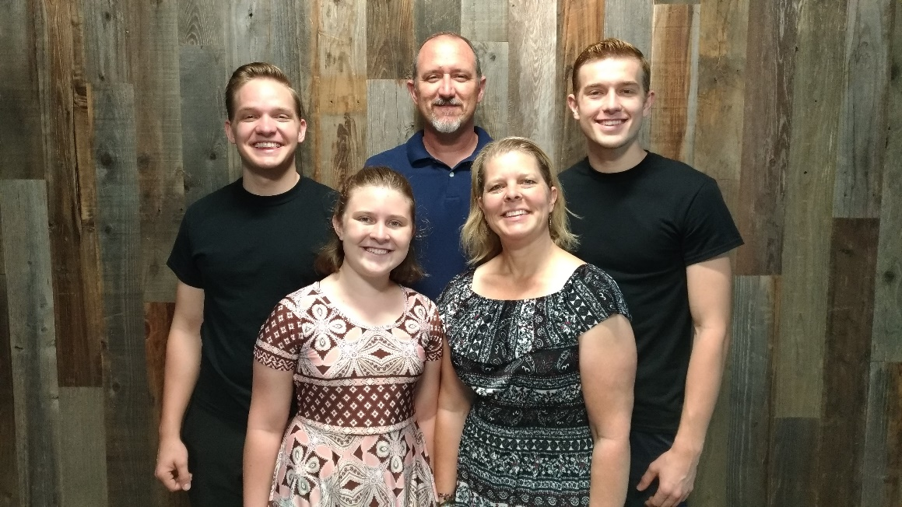Bruce and Candice Beatham are missionaries with Wycliffe Bible Translators in the mountainous southern state of Oaxaca, Mexico. They work with the Mixtec (MEES-tek) people in Coicoyán de las Flores and San Martín Peras, two poverty-stricken communities in this beautiful place in God’s world.

Besides translating the New Testament and parts of the Old Testament, they are also developing the written form of the language and doing literacy work to teach the people how to read and write their language. Bruce keeps busy with the translation and linguistics work in the language project. In addition to helping with administrative roles in their group, Candice is in charge of the project’s literacy work and homeschools their children—now only Abigail, since their three boys, Jeremiah (now married to another Abbie), Nathaniel and Benjamin, have grown up and returned to the US.

Benjamin, Bruce, Nathaniel

Abigail, Candice

At this time, they have around 60% of the New Testament drafted. Their recent work has been focused on polishing some of those books from draft form to publishable quality, and they pray that the Gospel of Mark will be ready soon, followed by Luke and Acts.

**God’s Buildings**

**God proved His love and faithfulness in providing a church building and parsonage … with many additions and changes … including a new place of worship in 2002.**

From the day of organization, the new congregation talked of building their own church. In November, 1904, a building committee was chosen consisting of Ole Alen, Andrew Palm, Andrew Peterson, and Peter Peterson. Land was purchased from Mrs. Francis Haskins on December 18, 1909, for $40 as the deed is recorded in the Polk County Courthouse.

Additional land was received as a gift from Lawn Randall in 1946 when the parsonage was built. Another 25 feet was purchased from John Randall in 1961 to enlarge the parsonage lawn.

In 1910 the church, with a full basement, was built at the cost of about $2,700. Money was borrowed from the Polk County Bank and from the Northern Baptist Convention. The old “kassa-bok” has a complete record of costs connected with the building.

The Svenska Baptist Forsamlingen of Bunyan, Wisconsin.

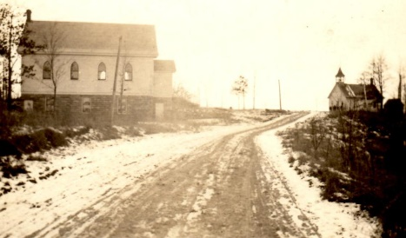

The road used to go around the east side of the pond by the old church building. East Balsam School is on the right-hand side of the road.

A baptistry was built into the platform. Electric power was not available until 1939, so for almost twenty years gaslights were used. There was a tank of gasoline in a room to the right of the platform with tubes leading to the light fixtures hanging from the ceiling of the church auditorium. The tank had to be pumped to create pressure and whenever the lights went dim someone had to go up and pump more air into the tank. These lights, which burned gas under pressure, were very noisy.

A wood furnace was installed for heat with a register in the front of the platform. At first, each family had to provide one cord of wood, sawed to 14-inch lengths. The sawing was to be done in the woods so as not to mess up the churchyard. Later, there was a wood-cutting day established when the men of the church would work together to cut a wood supply. Eventually, a wood committee was chosen to make arrangements for a wood supply. Wood was burned for heat until 1956 when a gas furnace was purchased.

One hundred chairs were purchased for $61.59. These chairs served as “pews” for 50 years until replaced by pews in 1961. Several chairs were nailed to a board to keep them in neat, orderly rows.

A pail of water and a dipper served as a source of drinking water. The communion grape juice was served from a silver cup that was passed from one participant to the next, each one wiping with a napkin the edge where he took a drink. In 1939, a communion set with individual cups was purchased to replace the common cup.

**Horse Barn/Garage**

In 1913, a horse barn was built to accommodate the faithful animals that brought the worshippers to church. This barn stood south of the church. Later a garage was built in approximately the same spot as the horse barn had been.

**Changes in the church building**

Church in 1943

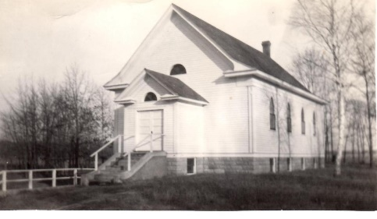1950—The church entry was enlarged to the north to enclose a stairway to the basement. This replaced a stairway originally located in a room to the left of the platform. The change made room for a Sunday School class upstairs and a kitchen in the basement.

1951—A mortgage held by the Northern Convention since 1910 was paid off. Pastor Ray Larson really encouraged the congregation to pay this debt.

In 1959, the church took on another “new look”. The old entryway was removed and replaced with a new entry that enclosed the steps, relocated the basement steps, included a nursery on first floor and rest rooms in the basement.

With the installation of indoor rest rooms, a problem arose about what to do with the outhouses. Some thought we might need them if the indoor plumbing failed to function. No decision was made at a business meeting, but Pastor Hulbert took care of the problem. The day after the business meeting he burned the outhouses! It saved a lot of time at future business meetings!

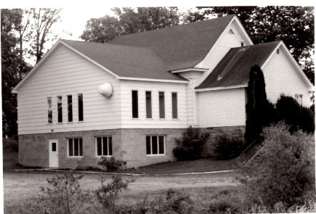1974—Money received from the Dahm-Gunlach estate, plus money borrowed from the bank, was used for a major building project to about double the size of the church, both basement and upper auditorium.

Dedication of the addition was a time of rejoicing at the 70th anniversary celebration in October.

In July of 1982, the decision was made to build a Sunday School Annex—a building separate from and north of the church. This provided space for four classrooms. The cost was about $15,000.

After the 1974 addition

In 1990 a ramp was added for easier access with a wheelchair or for those who found it hard to walk steps. The money was donated in memory of Geneva Ogren.

**God is Able and He is to be Praised!**

At the Annual Meeting on May 17, 2000, it was voted to build a new church. Money was given to the church to purchase 15 acres a mile north of the old site. Months of planning and working with Vanman, an architect firm, as well as fundraising, took place before the work was begun. The building, sound system, chairs, kitchen appliances, etc. cost approximately $800,000. This did not include the many hours of labor, or items donated by people who paid for items themselves. In August 2004, the church owed $355,227. Fifteen years later the balance is $37,065.

The theme ***GOD IS ABLE*** was chosen, and that has proved true over and over again.

Several “Prayer Walks” were held. People walked around the property praying for the building project and future ministry.

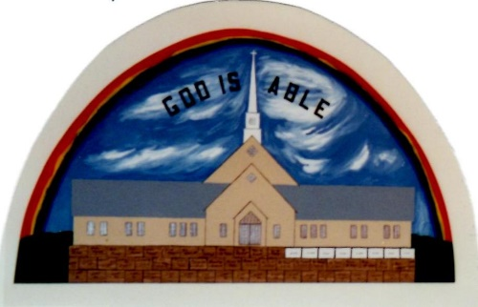Ground breaking was held on October 7, 2001, on the church’s 97th anniversary. Construction began two days later and continued throughout the winter. The building construction was hired through the installation of sheetrock. Volunteers did the rest. Many people worked long hours to complete the building. The bids came in lower than expected so two classrooms were included that were not in the original plans.

Cheryl Volgren made several Memory Albums of the building process. In one of the books she has a page with a rainbow and under it the ***GOD IS ABLE*** theme, with the following:

On June 12, the lights were lit up for the first time on the steeple. Driving past at 10:30 p.m.

was an awesome sight. All I could say was:

**THANK YOU GOD!!**

When we ordered the chairs we were told 90 days for a lead time. But I got a call in early

June saying they would be delivered either the week of the 17th or 24th of June!!

Why do you suppose God wants us to have them that early? We are listening God! But

also as they are delivered we will need to pay the balance of close to $6,000. Where was

that money coming from? God had that figured out too, someone graciously

covered the balance. Once again I could only say:

**THANK YOU GOD!!**

I am reminded of God’s faithfulness in so many ways. Looking at the trim as it goes up.

who would of ever thought of all the trees being blown down that they would end up

trimming our building?! Again I just say:

**THANK YOU GOD!!**

God has provided many people to give a hand to helping whenever they could. To these

people we say Thank You. And once again we say:

**THANK YOU GOD!!**

God provided in many ways. One was a windstorm that downed Oak trees. LeRoy Brown, Don Nelson, Robert Holin, and Bob Nelson donated the logs. LeRoy Brown provided the sawmill, and many men donated labor to saw them into boards, which became the trim and the cross for the church.

Another provision was for the $25,000 needed to blacktop the parking lot. The old building was sold in time to get the blacktopping completed before winter—on November 11, 2002. Mud and sand were being tracked into the building, which is hard on the carpet. We didn’t really want to face the spring thaw without blacktop.

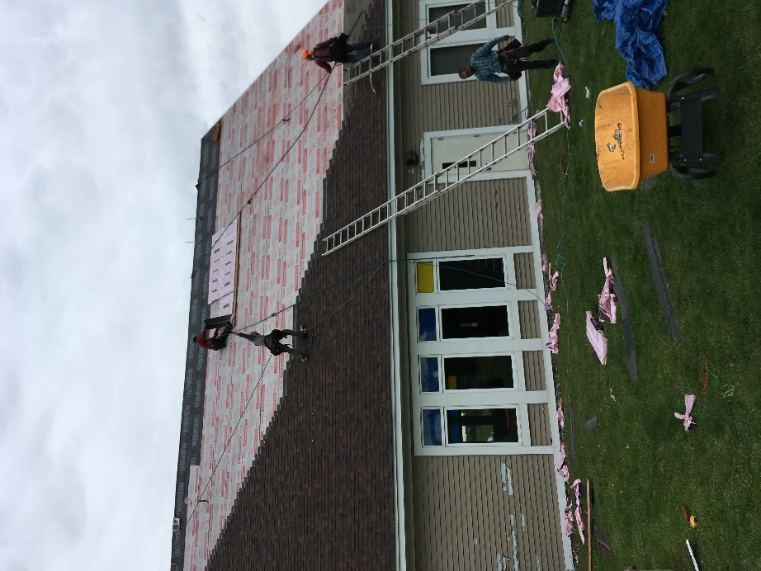

**God still providing through storms—**

Another storm came through the area in 2019. The church steeple was blown off the roof, shingles were damaged, the door on the storage shed damaged, and swing/slide set on the playground destroyed. The roof has been shingled and the insurance will pay all except the $500 deductible. The steeple and garage door will be replaced. The playground set will be replaced in the spring.

(right) Picture of shingles being replaced in September 2019.

**Parsonage**

In June of 1943 a decision was made to start a “Parsonage Fund”. One method of raising money to help build the parsonage was to have the Sunday School children buy bricks for the chimney.

The parsonage, built by the men of the church for about $5,000, was completed the summer of 1947 when Howard Olson was pastor. World War II had just ended and building materials were difficult to obtain. Pastor Olson’s father was in a position to help greatly in this matter. John Dahm was the chief carpenter.

Beginning in the Fall of 1987 to the Spring of 1989 the church took on an extensive remodeling of the parsonage. This included new windows, siding, roof, and an addition, which enlarged the dining area and provided a new entrance with a closet. Including painting, new carpet and flooring, the project cost about $15,000.

On July 26, 1994, the parsonage was moved from the spot near the church to a new plot of ground about half a mile south. The move provided more parking space, which was a real problem at the church site.

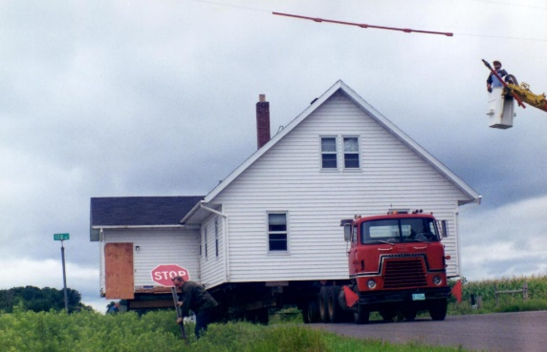

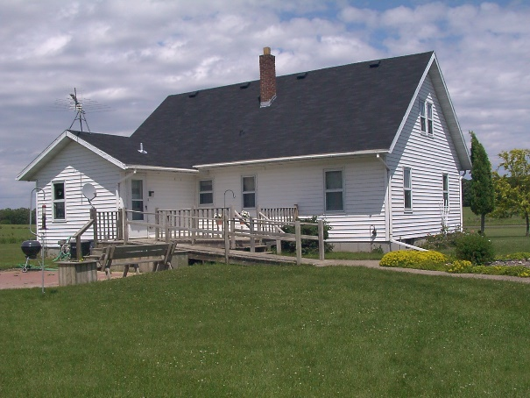

(above) The parsonage on the move! There were lots of wires and signs to slow the progress.

(right) The parsonage on the new lot.

**“O LORD,**

**Not to us but to Your name be the glory, because of Your love and faithfulness.”**

**Descendants of some of the charter members, or members who joined the church within a few years of it being established, who are still worshipping at East Balsam.**

**ALEN—**Peter Alen and his son Erick Alen were charter members. Miranda Andrews wed Erick Alen in 1918 and became a member in 1919. With Erick’s untimely death in 1924 she became a widow with two small sons, Paul and Irvin. Paul’s descendants who are still members are Darrel and Velda Alen.

**HOLIN—**Christina Alen, daughter of Peter Alen, was a charter member. She married Carl Holin in 1916. They had three children, Maybelle, Victor, and Robert; all three have passed away. Robert’s wife, Juanita, is a member of East Balsam and lives in Shoreview to be closer to her children. Victor’s descendants who attend EBBC are Kathy Thull (daughter), Jessica Bergman (granddaughter), and Jessica and Ben’s children, Caleb, Aliese, and Johanna (great-grandchildren).

**SWANSON—**Mr. & Mrs. Ed Swanson joined the church in 1921. They had five daughters and one son. Their daughter, Florence, is the mother of Edie Osborn who is presently a member.

**ARVIDSON/GUSTAFSON—**Carl and Edith Arvidson became members in 1924. Elmer and Signe Gustafson joined the church on November 12, 1944. Their children, Millie Arvidson and Arden Gustafson married and raised their family in the Twin Cities but spent many weekends at their cabin on Bone Lake. Millie and Arden’s daughter, Joy, married Clif Gustafson and have three daughters. The family who attends regularly in the summer is David and Marcy Swanson with their children, Emily Grace and Joshua who are the fifth generation.

**Future Ministry**

Vacation Bible School has been an important ministry to the children of EBBC and the community. The first VBS was held in 1937 and has continued throughout the years. A recap of the 2019 VBS is on the next page. We pray VBS will be continued for many years in the future.

A Youth Ministry for grades five through H.S. is beginning in September 2019, EBBC sponsors Good News Club which is held at Unity during the school year, Bible studies (one for men and one for women) are being held weekly, and special programs are held throughout the year. The Search Committee is working to find the man who will be our next Pastor.

**We are praying for God to continue His work at East Balsam.**

**VBS—July 22-26, 2019**

**THE INCREDIBLE RACE: ONE FAMILY, ONE RACE, ONE SAVIOR**

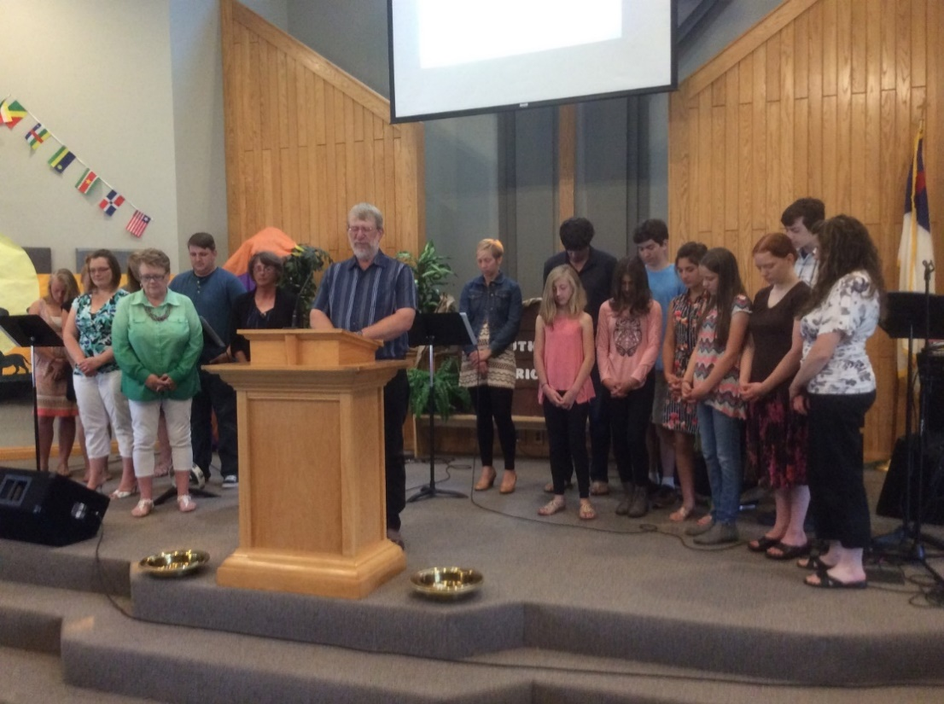

Volunteer teachers and staff came forward on June 23rd.

Larry Michaelson led in prayer for them as they work in VBS the coming week.

At this year's VBS, The Incredible Race, the kids learned about the one race that started in the Garden of Eden—the human race. Each day, 71 children and 35 staff traveled around the World. They made pit stops before, during, and after the Tower of Babel, showing them how this event from the Bible matters even today!

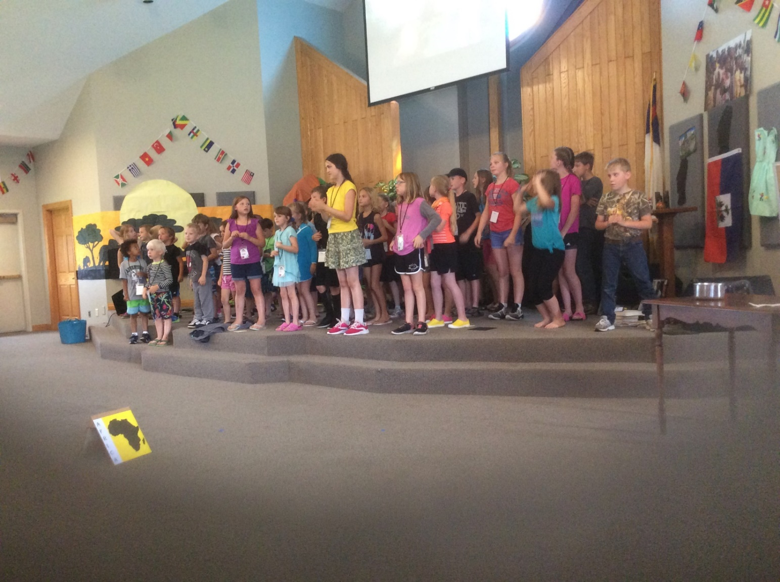Along with this, each day we had a missions moment. This year, we once again had Sarah Bowers share with us about Haiti and the orphanage she serves. She told us about the different people that support the children at the orphanage -nannies, teachers, pastors, and cooks.

Our goal was to raise $1000 for this orphanage. The girls and boys raced to beat each other in the amount each team raised. The boys won again this year and earned the right to pop the 60-inch water balloon! The total amount they raised was $1331.22! This is enough money to fully support a child for one year at the orphanage! What an amazing job they did. None of this would have been possible without the people who prayed, who helped get ready for VBS, teachers, parents, and the kids who came to VBS.