East Balsam Beacon Newsletter

November/December 2012


I remember as a little boy being very excited about Christmas. We had a tree in the living room with presents underneath and lights strung up around the house. I loved watching Christmas specials on television like “Rudolph the Red-nose Reindeer,” “Frosty the Snowman,” and “A Charlie Brown Christmas.” It was my favorite time of the year. One year, my family drove from Brainerd, MN, to Roberts, WI, to celebrate Christmas with cousins and aunts and uncles. On the way there, they were playing “Silver Bells” on the radio. I was immediately taken to a faraway, special (even magical) place called “Christmas” and I never wanted to leave. Perhaps you experienced Christmas like this when you were growing up.
Now that I have grown up (a bit), Christmas is not as magical or “otherworldly” as it used to be. Sometimes, I don’t feel any emotion at all during the Christmas season and the celebration comes and goes without much thought about it. But I think I am missing out. My childhood memory of Christmas as magical and blissful is a much better response than boredom and indifference. Christmas is about the coming of God in human flesh. Jesus came in the womb of a woman and was born into the world like every other baby. Jesus looked death in the face and went to battle with sin and Satan. This is supernatural, spiritual, mysterious and otherworldly. And for believers, this story is blissful. Sins removed from us. Guilt taken away from us. Righteousness given to us. The Christmas season should be welcomed with joy, wonder, and happiness, long after we kids have grown up.
Jesus says that to enter the kingdom of heaven, we must have faith like a child. And I think along with faith comes a good deal of awe and wonder. Paul says in his book to the Romans, “Oh, the depth of the riches and wisdom and knowledge of God! How unsearchable are his judgments and how inscrutable his ways!” That sounds like awe and wonder to me. When was the last time you thought of Jesus coming from a distant place to be born human and said to yourself, “Oh, the depth of the riches and knowledge of God. How unsearchable are his judgments and how inscrutable his ways!”? Does this incredible, otherworldly story still grip you? Does the story of Jesus’ birth still awaken pleasure in your soul? Does the coming of Christ still surprise you and make you feel unworthy? Or has the grateful, awestruck child grown into a Christmas Grinch?
I sure don’t want to be a Grinch this Christmas. This story of Christ coming to earth is the most amazing and beautiful story that has ever been told. The story has no rivals and will never be topped and cannot be compared to any great literature of our day or any other. So let’s tell this great story! Let’s tell it to our kids and grandkids and friends and neighbors. “Jesus, the Son of God, came to earth as a baby to take away the sins of the world.” That deserves a holiday!
Grateful to celebrate the birth of Jesus with all of you,
Pastor Gabe


Bible Study: We have recently started the study of Joshua. We are looking at the Scriptures to see that God is the main character of all Biblical narratives. The human beings are always secondary characters in a story about what God did.
On October 23rd after Bible study fifteen ladies attended a luncheon at the home of Joan Michaelson for a social time before two ladies (Pat Davis and Delores Nordling) head south for the winter.
Several ladies attended the Area Fall Rally at First Baptist Church in Falun on October 9th. The speaker teaches nursing in Africa. For her safety and the continuation of the work, she asked that we not use her full name. It was a lovely fall day for the drive north.

CHRISTIAN WOMEN –
November Meeting:
November 12th, 11:30 A.M. Luncheon
Zion Lutheran Church
28005 Old Towne Rd.
Chisago City, MN 55013
Special Feature: Silent Auction
Music & Speaker: Rachel Snodgrass
“In and Out of Control”

December Meeting:
December 10th, 9:30 A.M. Brunch
The Gallery
12975-292nd St.
Lindstrom, MN
Special Feature: Bianca Rider
“Rose Colored Glasses”
Speaker & Music: Holly Berry
“Playing For Keeps”

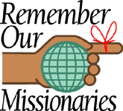
Bruce & Candice Beatham—Mexico
The Beathams arrived in Mexico 10 years ago in October. They are working with the Mixtec language group (approximately 25,000 people) and are still learning the language differences between all the different communities. Bruce and Candice are working with two different Mixtec groups. A married couple, Franciso and Socorro, are translating in the village of Peras with some help from Bruce. Pray for Franciso and Socorro. Also pray that Bruce and Candice can get a translator from their village of Coicoyan.
The Beathams report that they are doing well in Mitla. Nathaniel, Benjamin and Abigail are studying “’Space’...having a blast as well as learning so much!” Jeremiah was baptized on October 28th. Bruce & Candice had recently requested prayer for their kids as they were being attacked by Satan. They are still dealing with some things but are trusting God.

Steve & Carol Jean Gallagher—Papua New Guinea
Steve & Carol Jean Gallagher are in New Jersey until mid-December. They continue to speak at their supporting churches there. They are also editing the audio Scriptures in Bariai, a time-consuming task. Steve recently talked to the translation committee chairman in the Bariai area by cell phone. It was good to hear that attendees of the Bariai Bible course held in July have taught the first five of the 19 lessons to people in their villages. Deaths and associated funeral obligations, along with church activities, have delayed the continuation of these lessons. Pray that more lessons would be taught in November. Pray that the Holy Spirit would help those who teach the lessons to present them accurately.
Because of a change in policy, Carol Jean now needs her own work permit from the Papua New Guinea government. Her paperwork has been received by the SIL office in PNG. Pray that it would be submitted and processed in good time. By mid-December, offices begin to slow down for the Christmas holidays. They need this before their return to PNG, departing on January 7th.

Steve & Rhonda Schwarze – Faith Academy, Philippines
In October Steve & Rhonda had the privilege of attending the dedication of the Bolinao New Testament. Gary & Diane Persons (Wycliffe Bible Translators) began translation in 1977. It was not without great cost as Diane was killed in a car accident in 2003. All six of their children graduated from Faith Academy.
There are 18 translations currently in the process. “If we ever want encouragement to continue on working in the field of MK education, we just need to attend a Bible dedication or hear Bible translators share their ministry” is a quote from a recent letter sent by Steve & Rhonda.
Faith Academy is hosting a conference this week for Child Safety and Protection Network – awareness, prevention and care for abused children. Steve will be leading one of the workshops. People are coming from many countries.

Sewing Supplies to Mexico –
When I announced that sewing supplies and curtains/drapes can be used in Mexico, I knew very little about the project. In about three weeks 12 boxes and bags were gathered. They were delivered to the home of Keith & Sharon Kerssen near Lindstrom, MN. Sharon said the Mexicans live in small, dark houses and a curtain on the window or as a room divider brightens up their homes.
The Kerssens work with an orphanage where Sharon teaches sewing. She gave me some literature with a picture of Nena who grew up in the orphanage and was the first person from the orphanage who went on to college and became a teacher. The kids who now live in the orphanage sewed pencil bags (a cloth bag with a zipper) for each of Nena’s 40 students. They put pencils, an eraser and pencil sharpener, and a Christian tract – bilingual copies of Four Spiritual Laws – into the pencil bags.
One lady shared her copy of Four Spiritual Laws with a young mother who prayed to receive Jesus, who in turn led two friends to Jesus. PRAISE THE LORD!!
Keith & Sharon have started a loan program with extra sewing machines which they lend to the different churches. The machines can be used for a year or until they quit working. They then bring the machine back and Keith repairs it.
You can continue to save sewing supplies, curtains, drapes, and pencils (don’t need to be new) which we will collect next fall. I have directions if anyone wants to sew pencil bags.

Joan Michaelson

Family Fun
Night
A family fun night was held on Saturday, October 13th. We enjoyed a meal together, along with a campfire and a sing along with Pastor Gabe leading and playing the guitar.

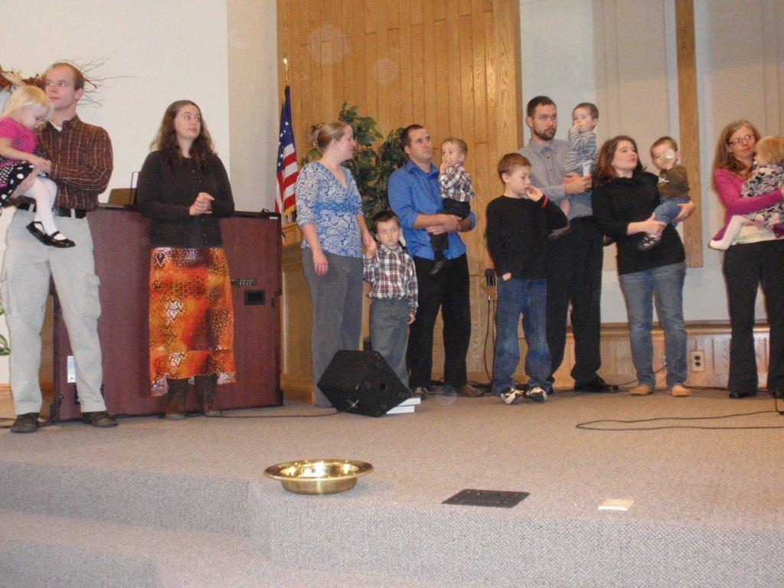
A child dedication service was held on October 28th. The following children were dedicated:
- Miranda Rose Alen
- Isaiah Montgomery Moe
- Laurel Lyn Moe
- Jonah Gabriel Brennan
- Vincent Julius Stoltzman
- Judah Nathaniel Stoltzman
- Benjamin Uriah Stoltzman
Their parents promised to dedicate them to God and to bring them up in His instruction.
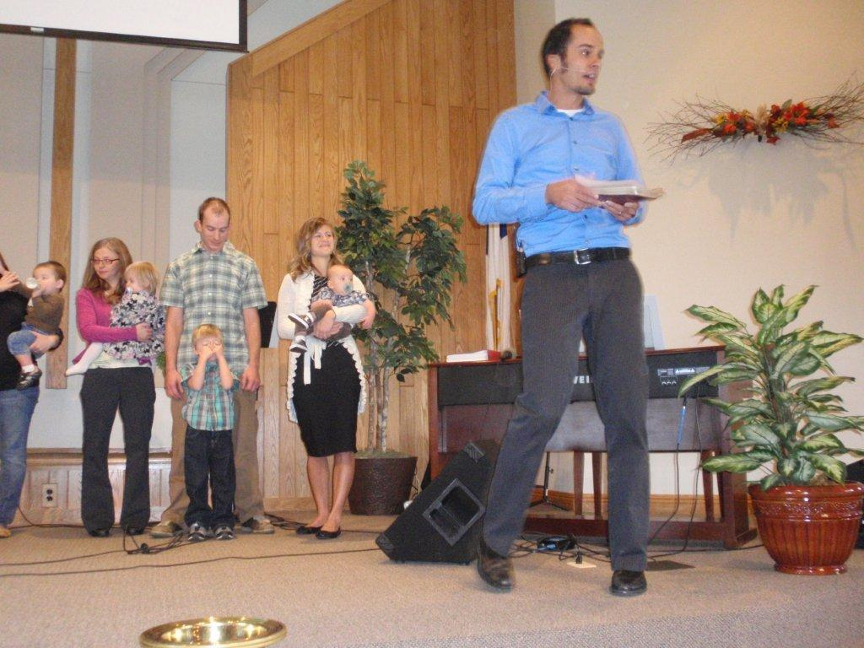
As of October, we now have a $1,130.00 balance in our general fund. This is the fund to pay all our church's operating expenses. A big thank you for your giving in October as our balance went up about $500 from September. We continue to be concerned about our
projected balance in this fund over the next several months- particularly during the winter. If you are able to make any additional contributions, it would be very much appreciated.

Are you a parent interested in having your child learn an instrument? Pastor Gabe is offering free lessons to any kids (from age 10 and up) wanting to learn drums or guitar. Lessons would probably be done on Mondays and Tuesdays after school. Please talk with Pastor Gabe if you are interested!

Lawnmower
The parsonage lawn mower needs a tune-up. Anyone willing to volunteer to do this, please contact Phil Foster. He can deliver and pick it up from you.

November 21st—7:00 p.m. – There will be a Thanksgiving Eve Service. Come, join others in thanking God for our many blessings, and then enjoy a time of fellowship and pie.

December 16th—9:00 a.m.—There will be a Christmas Program. The children will act out the Christmas story during the morning worship hour. Everyone is then invited to a birthday party for Jesus (cake and ice cream).

December 24th—4:00 p.m.—There will be the annual Christmas Eve service. Come join us to celebrate Christ’s birth.


November
Erin Mabry 3
Greg Cloutier 4
Joy Gustafson 11
Roger Peterson 12
Nathaniel Beatham 15
Fred Salmon 17
Steve Gallagher 18
Chuck Steege 18
Carol Jean Gallagher 22
Scott Anderson 24
Joe Conlan 28
Adam Gallagher 28
December
Tyler Haney 1
Tim Dulas 5
Bruce Beatham 10
Candice Beatham 13
Samantha Potvin 15
Barb Jarchow 17
David Thaemert 17
Ashlyn Majeske 18
Randy Nelson 19
Jasmine Morales 21
Theressa Morales 21
Heather Morales 21
Samuel Majeske 22



East Balsam Baptist Church
1816 108th St./Co. Rd. I
Balsam Lake, WI 54810
www.eastbalsam.org

Sunday Worship—9:00 a.m.
Sunday School—10:35 a.m.
Tuesdays—Women’s Bible Study—9:00 a.m.
Thanksgiving Eve Service—November21st
Christmas Program—December 16th
Christmas Eve Service—December 24th

Pastor Gabriel Brennan—gabriel.brennan@gmail.com

