East Balsam Beacon Newsletter

July/August 2012


Well, the summer of 2012 is coming to a close. It has been a busy (and hot!) summer for most of us and I am thrilled at the work God has done in our church. In June, we celebrated three baptisms and we hope to see many more in January! In July, we brought in a bluegrass band, ate barbecue and played games on a (very) hot Saturday afternoon. And in August, we hosted Vacation Bible School. This was a great week of meeting kids, learning scripture and singing songs about Christ, our great Treasure. Thank you to all those who so graciously and joyfully volunteered!
Now as we enter the fall months, what should we expect? On September 30th we will be having a Child Dedication class and then a New Members class in October. These classes are meant to establish our church as a Christ-centered and God-glorifying church committed to our families and committed to the local body. I spend a lot of time thinking and praying about the direction God is leading us as a church. And I often return to relational commitment and relational health, both within our human families as well as our spiritual family. The church thrives on healthy relationships that are centered on the Word of God. If you have thought about church membership or about dedicating your child to God, please come out for these classes. They will be a tremendous blessing to you.
On a personal note, Melonie and I recently returned from vacation in Denver, Colorado. What a beautiful place! It was very nice to get away and see the vast expanse of Estes Park and the Rocky Mountains. Jude and Jonah were real troopers, riding our backs for 15 miles of hiking! The mountains reminded me of the permanence and unchangeable nature of God. He is a rock and fortress. We trust in Him alone to sustain our church and lead us in the days to come.
As we enter the fall season as a church, please consider what ways God is calling you to a life of deeper faith and love for Jesus and His Church. The book of James has been an important reminder that the life of the Christian is a life of action and growth. So let’s act and grow together for His glory!
Joyfully trusting Christ, our great Shepherd and Leader for all seasons,
Pastor Gabe


Bible Study: After a couple of weeks off (one being the week of VBS) we are still in the book of Exodus. The Israelites complained and grumbled after three weeks in the desert without water even though God had performed many miracles. We decided we would have done the same thing! And God watches over us just as He did the Israelites.
The ladies who attend benefit from the study and enjoy the fellowship with sisters in Christ. Ladies of all ages are invited to join us on Tuesday mornings at 9:00 (coffee & fellowship) with Bible study from 9:30 to 10:30.
On Tuesday, August 28th, we enjoyed a fish fry at the home of Pat Davis after Bible study. There were 14 women and four men from the Men’s Bible Study. Pat shared her testimony of how God has worked in her life.

CHRISTIAN WOMEN –
September Meeting:
September 17th, 11:30 A.M. Luncheon
Oak Forest
2824-130th St.
Frederic
Music: Judy Widmeyer
Speaker & Special Feature: Alaine Sonnenberg “How Healthy Is Your Heart?”

October Meeting:
October 15th, 11:30 A.M. Luncheon
Wapogasset Lutheran Bible Camp
738 Hickory Point Lane
Amery
Special Feature: Gayle Zinda
“Looking Great to Feel Awesome”
Speaker: Gayle Zinda
“The Lemonade Stand...
A Place to Come and Be Refreshed”


Bruce & Candice Beatham—Mexico
Dear EBBC family,
Hi, we hope and pray that you all are well. We had a whirlwind summer with various activities. We left our village of Coicoyán (coy-coy-YAHN) mid-May to go to Mitla in order to help put on graduation as is required by the families of the juniors. We then got Jeremiah on a plane to Wisconsin so that he could get a summer job. I guess some of you heard from him at VBS.
Then we had a couple from our second village of San Martin Peras (SMP), Francisco and Socorro, join us in Mitla to attend two workshops – one on linguistics and one on translation principles. We pray that God uses this training in their lives to help them work more independently on the translation, especially since they live in a village over an hour away from ours, but also so that they can produce a better, more accurate translation. Please pray for Francisco and Socorro as they translate God’s Word into the Mixtec (MEES-tek) spoken in their village and also as they will soon be parents. Socorro is due early-September.
After that, the five of us went back to Coicoyán to continue work on translation and literacy. We as a family have started spending an hour twice a week at Bruce’s office offering our services as “English experts” for people who want to practice speaking and learn more English. We also hosted some Mexican missionary candidates who are interested in doing translation and literacy work somewhere in the world.
In August we went back to Mitla to pick up Jeremiah from the bus station. After working in Wisconsin for the summer, he flew to back to Mexico City and took a bus from there to Oaxaca City. We praise God that he and the teacher he travelled with were safe. A week later two teenage friends of his were robbed at gun-point on a bus going that same route. The same morning that Jeremiah got in (Bruce went to pick them up at the station and got home at 3:15 a.m.!) we left for some relaxation and family time with Jeremiah at the beach for a week. It was a near-perfect vacation!
Jeremiah began his senior year at his school in Oaxaca when we returned (a few days late). Time flies! The rest of us left for the village a few days later. We, too, have started home schooling again and are looking forward to a great year! We are going to be very busy with Nathaniel (7th Grade), Benjamin (6th Grade), and Abigail (1st Grade) all vying for Mom’s attention!
Pray for the situation with our linguistic center in Mitla as a local group is claiming that we don’t own the land legally. Pray that this can be resolved in a way that God will receive the glory. Please pray also that we will allow God to do all that He wants to do in and through us for His glory! Thank you for walking with us on this journey. May God bless you!

Love,

The Beathams
Bruce, Candice, Jeremiah, Nathaniel, Benjamin and Abigail

Steve & Carol Jean Gallagher—Papua New Guinea
The dedication of the Bariai Bible was July 7th and 8th. It was a big event in the Bariai villages. About 100 Bibles were sold on the 8th.
For two weeks following the dedication other Papua New Guineans and missionaries conducted a SALT course (Scripture Application and Leadership Training). One woman said, “Having the Bariai Scripture is making God’s word so much more clear to us. We finally understand the ‘big’ words that were never very meaningful to us when we only had the Scriptures in Pidgin.” Others who attended the SALT course said they’ve discovered new freedom and depth in their relationships with Christ.
Continue to remember the Bariai people in prayer – that many will accept Christ as their Savior and they will grow in their walk with God.
Shortly after the Gallaghers returned to the U.S., they were informed that twice their house in the Bariai village had been broken into. Pray that God can use this situation for His glory.
They are in New Jersey until mid-December when they return to Wisconsin for about three weeks before returning to PNG.

Gil & Norene Zinke—Leadership Resources
Gil Zinke grew up in Japan as the son of Baptist Conference missionaries. He and Norene served in Japan for many years but Gil is now working under Leadership Resources.
On August 12th Gil spoke in the worship service on the topic of depression.
During Sunday School he told about his work with Leadership Resources. Their strategy is called TNT (Training National Trainers). They teach gifted leaders “How to Preach”, “How to Pastor”, and “How to Live and Serve”. They teach a group of pastors or church leaders who in turn equip or mentor other groups of pastors and church leaders. Gil travels to Vietnam, Indonesia, Papua New Guinea, and other countries in that area of the world.
Norene would like to come with Gil, however, she cannot travel from Wheaton, Illinois, because of problems with her back.

Steve & Rhonda Schwarze—Far East Broadcasting
On August 7th an email was received from Steve and Rhonda asking for prayer for the Philippines. They were in the midst of torrential rains and flooding. Faith Academy is on high ground so they were not in danger there but thousands of people were being evacuated and some had lost their lives. They had 18 ½ inches of rain in 22 hours on top of a solid week of rain before that. There has been no further word on the situation.

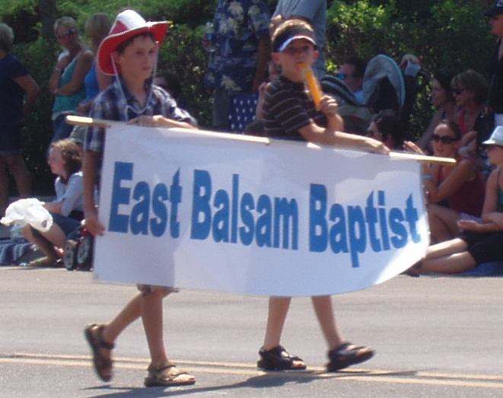
On July 1st, our church took part in the Balsam Lake Freedom Fest parade. We had a float and gave away popsicles.
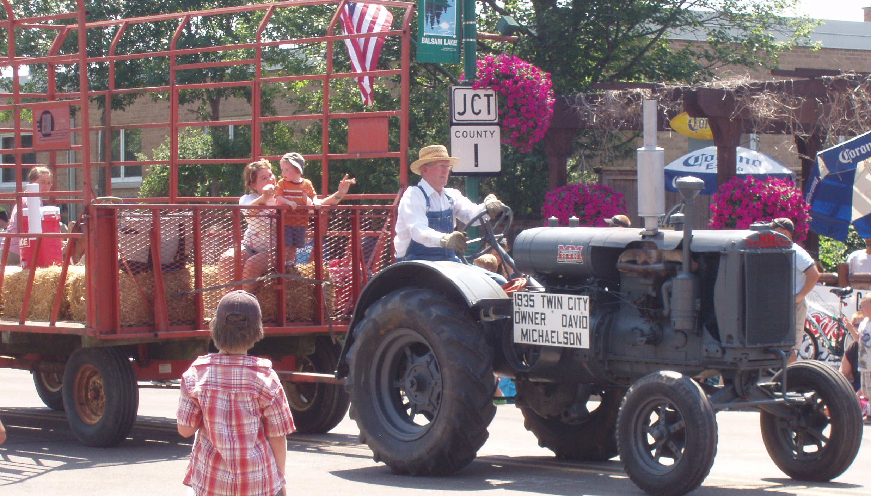


We had a community outreach and family picnic on Saturday, July 21st. The festivities included volleyball, croquet, kickball, barbecue grilling, and a bluegrass band, The Ophoven Family. The party kicked off at 4:00 p.m. with dinner at 5:00 and the band at 7:00.

Baptism
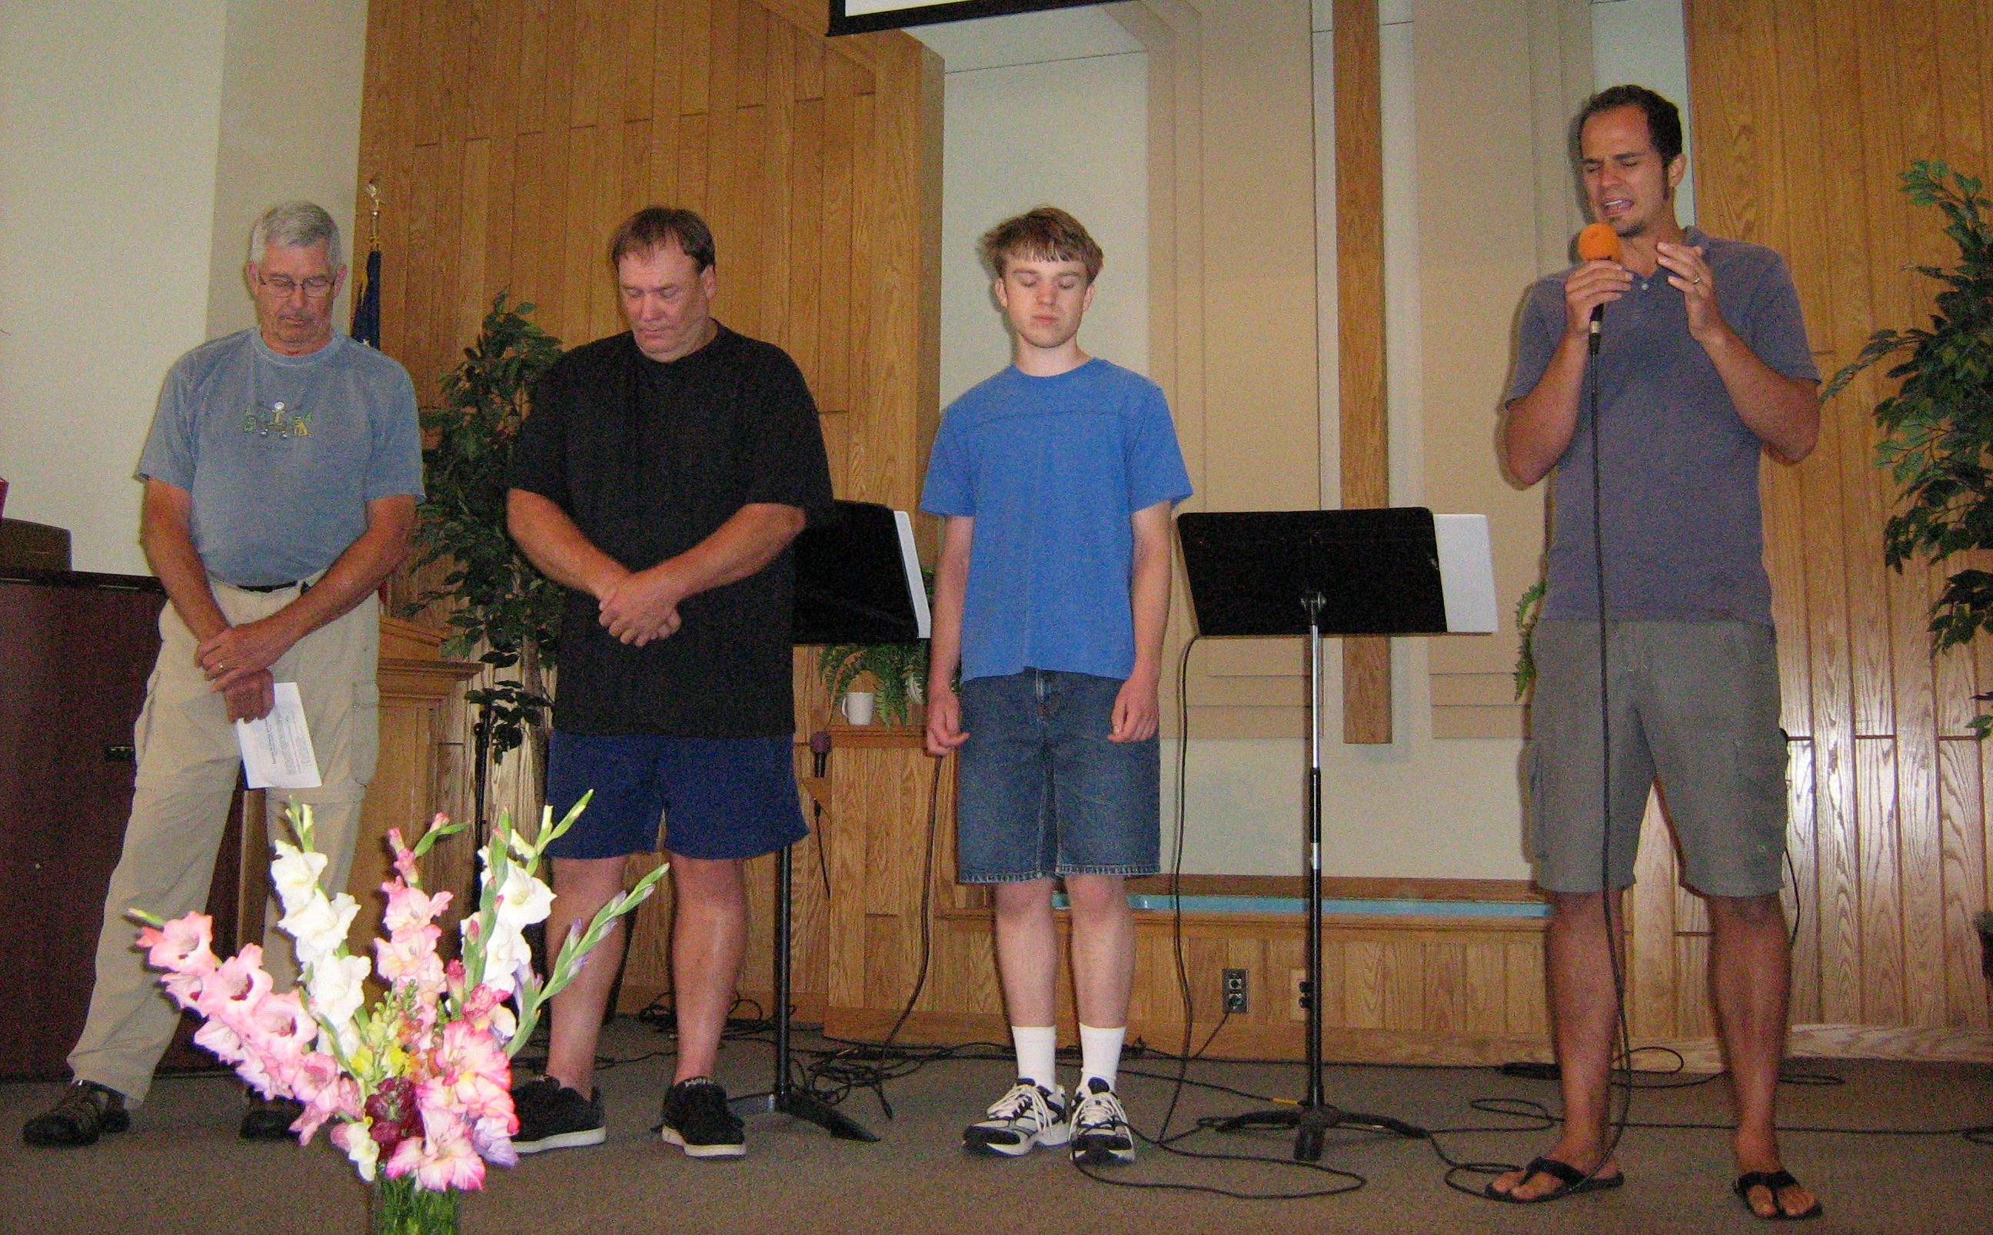
A baptism service was held on July 22nd. Scott Andersen, Walter Rodke, and Dale Michaelson were baptized during the morning service. Before being baptized, each shared what being a Christian means to him.


Bible school was held on August 6th-10th with the theme “Gold Rush: Discovering the Rock of Ages.” Forty-three kids were registered for the week. They took part in an opening and closing service each day along with classes, games, crafts, and snacks. There was a program put on by the children on the last day to show their parents what they had learned during the week. It was a successful week. Thank you to all the volunteers who helped out.

The church picnic was held on August 26th. It was a brunch, with pancakes provided by the ladies in the kitchen. After the meal, people were able to guess how many M&Ms and small candy bars were in jars, and the children had fun in the sawdust pile.

We have installed a first aid cabinet in the kitchen. We have also put a defibrillator in the bookcase in the fellowship hall. Currently Pastor Gabe is trained to use it. We will have a training session for others, so please contact Phil Foster if you are interested.
Safety Update

September 30th – 10:30-Noon – There will be a Child Dedication Class. A Child Dedication will probably be held sometime in October.

October 21st & 28th (time to be announced) – There will be a New Member Class.


September
Theresa Nelson 6
Dick Gaydosik 9
Levi Worrell 11
Gavriel Alen 15
Miranda Alen 24
Kathy Thull 26
Mike Jarchow 27
October
Jacquelyn Kelly 1
Isaiah Moe 3
Don Nelson 3
Ryan Hanson 4
Krista Moe 4
George Bertram 7
Marcy Swanson 15
Judy Priebe 16
JC Bump 22
Pat Thull 22
Donna Mabry 24
Mark Mabry 29
Adam Majeske 30



East Balsam Baptist Church
1816 108th St./Co. Rd. I
Balsam Lake, WI 54810
www.eastbalsam.org

Sunday Worship—9:00 a.m.
Sunday School—10:30 a.m.
Tuesdays—Women’s Bible Study—9:00 a.m.
Child Dedication Class—September 30th
New Member Class—October 21st & 28th

Pastor Gabriel Brennan—gabriel.brennan@gmail.com

