East Balsam Beacon Newsletter

July/August 2012


"The Gospel for All Places"
Do you think the gospel is applicable in all situations of life? Does the gospel have anything to say about lewd photos in a men's bathroom? I think yes. I was sitting at a table having breakfast with a fella from the church. I excused myself to use the bathroom. Plastered on the wall of the bathroom in the most noticeable way possible was a nearly pornographic picture of several women. I was saddened, not because God created sex and sexual attraction (which the restaurant owner was appealing to) but because the goodness of God's creation was being diminished. Men (and boys) were being trained to think of women as objects rather than people created in the image of God for His glory.
So what does the gospel have to say in that moment? Is the gospel as relevant in a men's restroom as it is in the pew of the Church? Again, I think yes.
God says that humans are created in the image of God. That means that they have inherent dignity and honor above any other created thing. Men are created to image and reflect God. Women also are created to image and reflect God. For this reason, humans are precious creations, fashioned by God's own hand for God's own glory. And men are specifically commanded to honor women. Paul tells Timothy to treat older women as mothers and younger women as sisters "in all purity" (I Tim. 5:2). And in Ephesians he tells husbands to love their wives "as Christ loved the Church" (Eph. 5:25). These are not heavy handed commands. These are natural responses to Christ's treatment of us. Jesus came not to be served but to serve. He came not to please Himself but to please the Father.
So, I walked out of the bathroom and back to my table. After a little while, the waitress gave us the check and I took the opportunity to ask her about the picture. She fetched the owner. After about a 3 minute explanation of why I thought the picture should be replaced (mainly for all the little boys who will see it), I said thanks and we left. I'm not sure if the picture will be taken down (and I don't think it matters all that much in the big scheme of things.) There will be other posters up in other bathrooms and boys and men will have more opportunity to participate (perhaps unknowingly) in diminishing the goodness and beauty of God's creation. But for that little corner of the world, I hope that the gospel shines bright. I hope that that owner feels the weight of human worth. I hope that if enough of us seek to light a candle of God's glory in all places, that we see the kingdom come here on earth. That is not an impossible task. And I think we ought to work for it in every opportunity God gives us.
In a few weeks, 3 of our men will be getting baptized at the church. This signifies the work of Christ in calling, convicting and redeeming lost people! This is a miracle that I can't wait to be a part of! May we as a church continue to broadcast the gospel throughout this town and community. May men treat their wives and women in their lives with immense honor and dignity. And may we all demonstrate the great love of Christ in all our relationships. "Therefore be imitators of God, as beloved children. And walk in love, as Christ loved us and gave himself up for us, a fragrant offering and sacrifice to God." (Eph. 5:1-2)
Joy-filled and grateful to be your pastor,
Gabe

WOMEN’S MINISTRIES
The women’s Bible study has finished the book of Genesis and enjoyed it so much that they have begun Exodus.

After Bible study on June 19th, about 12 ladies enjoyed lunch at the home of Sally Mackey to have fellowship and wish Nita Holin well on her move in July to an apartment in St. Paul.

CHRISTIAN WOMEN
July Meeting:
Monday, July 16th, 2012—11:30 a.m. Luncheon
Place: Camp Oak Forest, Frederic, WI
Special Feature: Sue Hager “Can Do Canines”—Service Dogs for Returning Veterans
Music: Cherie Everson Quartet
Speaker: Scott Gottschalk “Are Angels for Real?”
Contact Carrie at 651-257-4741 for reservations.
August Meeting
Monday, August 20th, 2012—11:30 a.m. Luncheon
Place: The Arc, Osceola, WI
Special Feature: Linda Stai “Storytelling Through Drama and the Written Word:
Music: Kris Palmer
Speaker: Linda Stai “You Control Your Life: True or False?”
Contact Velda Alen for reservations.


Gil & Norene Zinke—Gil teaches in Asian countries with Leadership Resources—
Gil spent two weeks in Borneo, then spent some time in Japan helping with tsunami relief and interpreting for a team for Bethlehem Baptist Church.
Their son Dann graduated with a 2-year associate degree from Bethlehem College and Seminary, and T.J. has started a 2-year grad program in Athletic Training at the University of Tennessee, Chattanooga.
Norene requests prayer for their two boys – that God will provide jobs and direction in their lives. She also requests prayer for her back that has given her trouble for several years but recently got worse. A MRI showed a herniated disk.
Our prayers and support for their ministry is much appreciated.

Steve & Rhonda Schwarze—Faith Academy, Philippines—
After three years of living in Iowa to be near Rhonda’s aging parents (both have now passed away), they are back at Faith Academy. Steve has “commuted” to work by flying fairly often to the Philippines during these three years so they are glad to be back to their place of ministry. They are in need of about $2,000 to repair their van. If you would like to contribute, you may put money in the offering and mark it for “Schwarze Vehicle Repair Account”.

Bruce & Candice Beatham— Wycliffe Bible Translators, Mexico—
Francisco and his wife Socorro have been attending workshops on translation principles. Bruce & Candice request prayer that they will continue to work with the translation.
Their oldest son, Jeremiah, has graduated from high school and come to Wisconsin to work at Hunky Dory for the summer. Nathaniel and Benjamin are studying German and learning to play guitar this summer.
Pray for the translation of God’s Word into the Mitxtec language.

Steve & Carol Jean Gallagher—Wycliffe Bible Translators, Papua New Guinea—
After 20 years the translation of Genesis, Exodus, and all of the New Testament is translated and printed in the Bariai language. A big celebration is planned for the dedication on July 7th and 8th. The Bariai people have been working hard in their gardens to have food to feed the people who will attend the dedication. Carol Jean and Steve have been working hard to have an audio version of Genesis edited and on a disk so they can be distributed that weekend.
Pray the Bariai people will read God’s Word, ask Him to come into their lives, and change their lifestyle.
Adam recently graduated from high school. Erin finished her sophomore year at Bethel University and left the next day for PNG. The family will be returning the end of July; Carol Jean and Steve will go back to PNG in January.

A membership class was offered on April 22nd and 29th. After this class, several new members were voted in at the annual meeting on May 16th. They are:
- Dick & Joyce Gaydosik
- Jason & Genie Bump
- Linda Bibeau
- George & Betty Bertram
- Mike & Katie Alen
- Gail McKenzie
- Gabe & Melonie Brennan
- Dawn Michaelson

NEW MEMBER SUNDAY
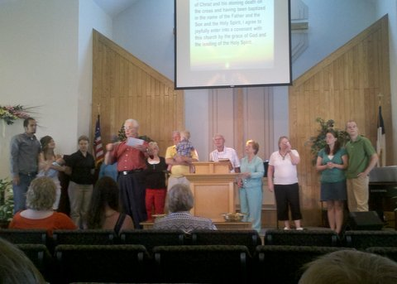
June 10th was New Member Sunday. The new members went up and took the membership covenant.

A Baptism Class was held on June 24th during the Sunday School hour. All three participants in the class are going to be baptized on July 21st.

NEW OFFICERS
New officers were elected on May 16th at the annual meeting. They are:
- Clerk—Joan Michaelson
- Treasurer—Larry Michaelson
- Financial Secretary—Lois Steege
- Deacons—Chuck Steege and Darrel Alen
- Deaconess—Theresa Nelson
- Trustees—Phil Foster and Steve Volgren
- Sunday School Superintendent—Val Rowe

Congratulations
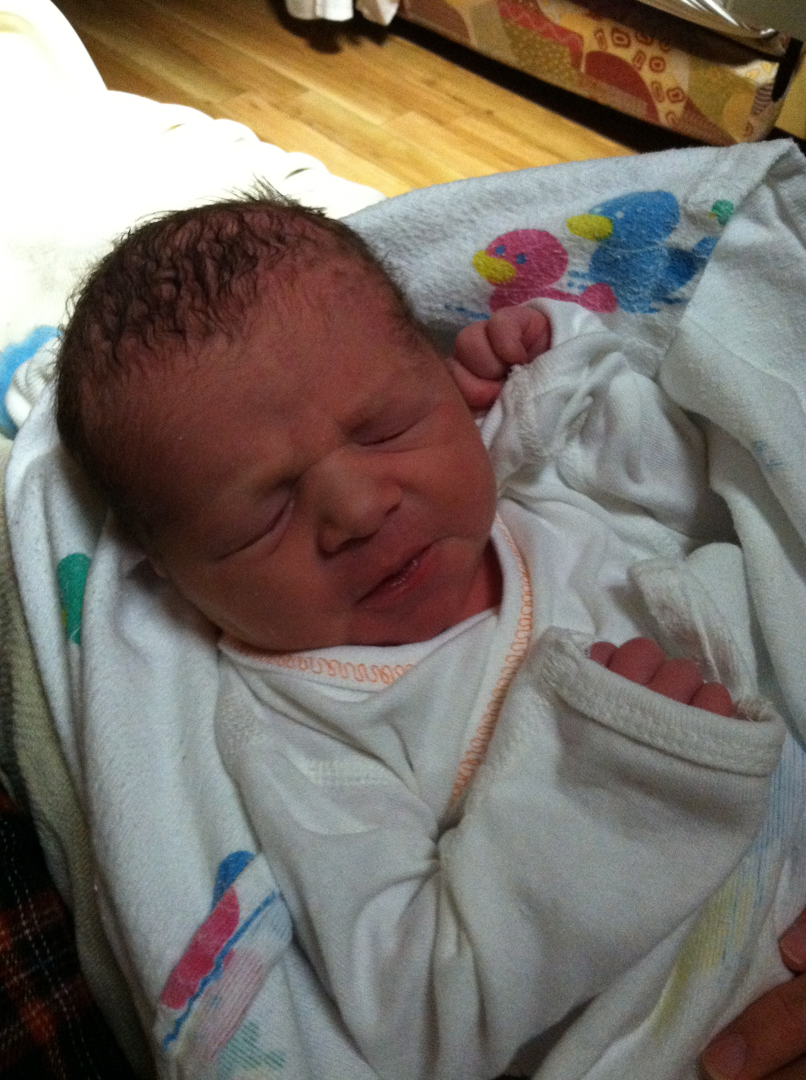
Congratulations to Pastor Gabe and Melonie Brennan on the birth of their son, Jonah Gabriel, on May 23rd at 2:09 a.m., weighing 7 lbs. 13 oz., and measuring 21 ½ inches.

Courageous
Movie Night
On Saturday, June 2nd, we held a pizza/chili and movie night. Over sixty people attended, which included about fifteen youth. For dinner we had six varieties of pizza which we baked at church but came from Flying Pie in Luck. Doug Waller prepared some outstanding chili which was a real hit. At 6 p.m. the adults watched the movie Courageous and the youth were treated to a lot of outside games by three outstanding hired sitters. Some of the youth also watched the movie Jonah—a Veggietales movie for some of the time. We had an intermission with popcorn.
The movie Courageous is a tremendous movie which tells of the importance of the man being the spiritual leader in the family and being a good husband. The movie highlights a document which men can use to commit to being a good husband and father–the document is called The Resolution. Phil Foster has copies for your use. Gabe has the movie which you can borrow.
At the Courageous movie conclusion, Scott Andersen shared the meaning of the movie to him and how he shared it with his family. Everyone concluded the evening with brownies ala mode.
It was a fun evening of fellowship and spiritual growth. The evening was sponsored by the Men's Group but also had help from Sarah Andersen and Sue Foster.

We will be having a community outreach and family picnic on Saturday, July 21st. The festivities will include volleyball, horseshoes, lawn golf, tether ball, barbecue grilling, and a bluegrass band. The party will kick off at 4:00 p.m. with dinner at 5:00 and the band at 7:00. Please come and invite your friends and neighbors!


Our church will be having a Vacation Bible School during the week of August 6th. The theme will be “Gold Rush: Discovering the Rock of Ages.” It will be Monday through Friday, 9:00 a.m. to noon.

ADDRESS CORRECTIONS
The e-mail address for Al & Emily Taylor in the 2012 Directory is incorrect. The correct address is emialtay@yahoo.com – it is ia instead of ai.
Clif & Joy Gustafson’s email address in the Church Directory is their old one. The correct address is clifandjoy@q.com.
Nita Holin will be moving in July. Her address will be 4655 Victoria Street North, Shoreview, MN 55126.

July
David Swanson 4
Heidi Johnson 7
Don Jensen 9
Brittny Cloutier 10
Steve Volgren 11
Bruce Peterson 12
Lindsey Bump 14
Lumiana Haney 21
Darrel Alen 23
James Carlson 26
Steven Pomerleau 26
Shirley McClain 28
Edie Osborn 28
Vincent Cloutier 29
August
Juanita Holin 7
Velda Alen 11
Roxanne Osborn 12
Laurel Moe 16
Kim Dulas 17
Lois Steege 18
Ryan Alen 21
Emily Grace Swanson 21
Kayla Johnson 24
Kelsy Johnson 24
Markus Majeske 24
Barb Michaelson 26
Iris Nelson 29
Grace Alen 30
David Michaelson 31


Sound Booth
Do you have a love for music and computers? If the answer is “Yes” then we could use you on our tech team in the sound booth. This is a great ministry with lots of potential for opportunities.
See Pastor Gabe for details.

Housekeeping
We still need volunteers to help with the church cleaning each week –this will take about an hour. We have hired someone to clean the carpet/tiles/windows every two weeks so the weekly cleaning by volunteers is minor. There is a sign-up sheet on the table for the volunteer work and the list of duties.

Volunteer Drivers
Do you love helping people who may be less fortunate?
Would you love to help a kid or adult who needs a ride to church?
If so, please contact Pastor Gabe.


East Balsam Baptist Church
1816 108th St./Co. Rd. I
Balsam Lake, WI 54810
www.eastbalsam.org

Sunday Worship—9:00 a.m.
Sunday School—10:30 a.m.
Tuesdays—Women’s Bible Study—9:00 a.m.
Community Picnic—July 21st
Bible School—August 6th-10th

Pastor Gabriel Brennan—gabriel.brennan@gmail.com

